**Project Title: The Foodie Zone**

(By SEMESTER – VI of III Year M.Sc. (CA & IT) 2022-23)

Submitted By:

Student Name: Roll No.:

1. Tirumal Boga – 3093
2. Krushal Joshi – 3111
3. Deep Patel – 3175

**Group ID: 43**

Name of Company: CreArt Solution

Date of Submission: 24/04/2023

Submitted To

K. S. School Of Business Management

M.Sc. – Computer Application and Information Technology



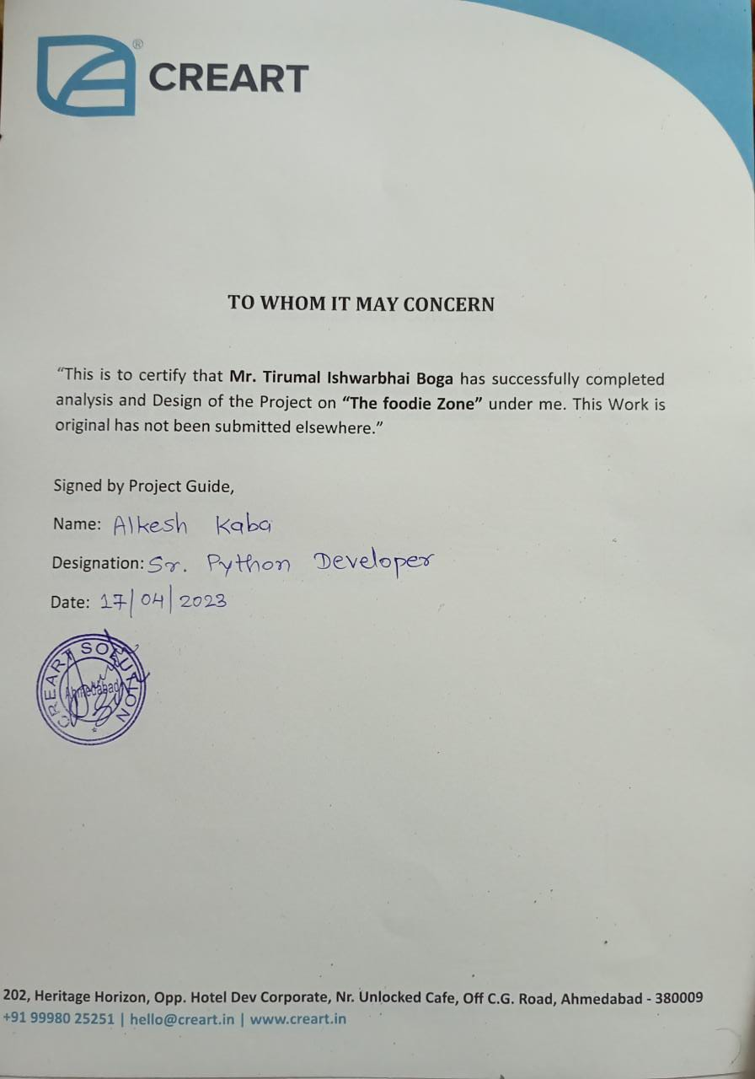

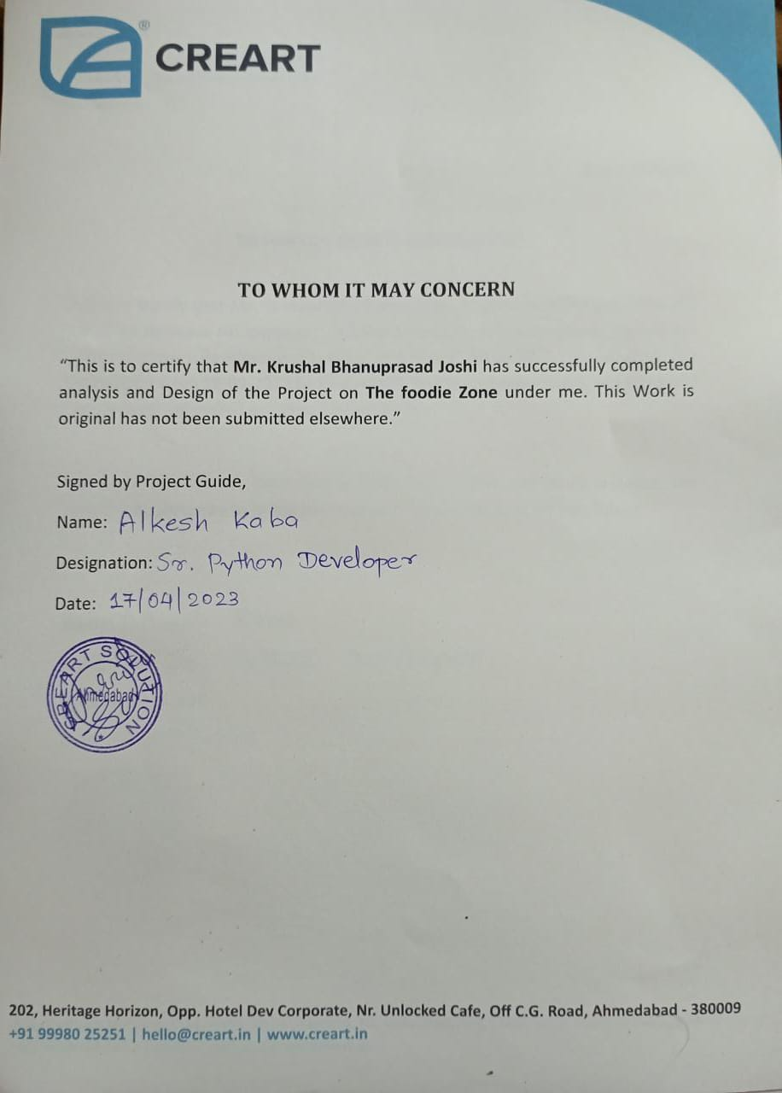

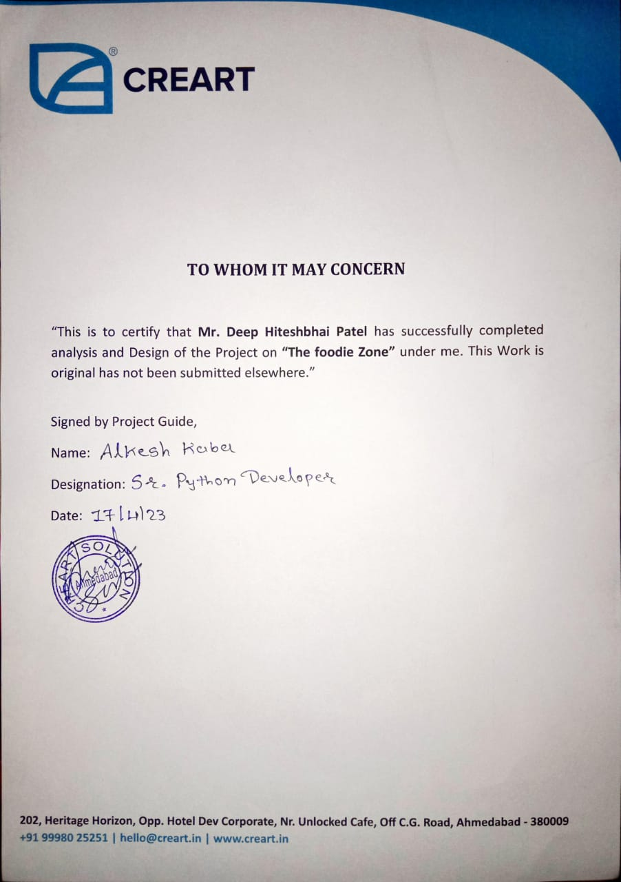

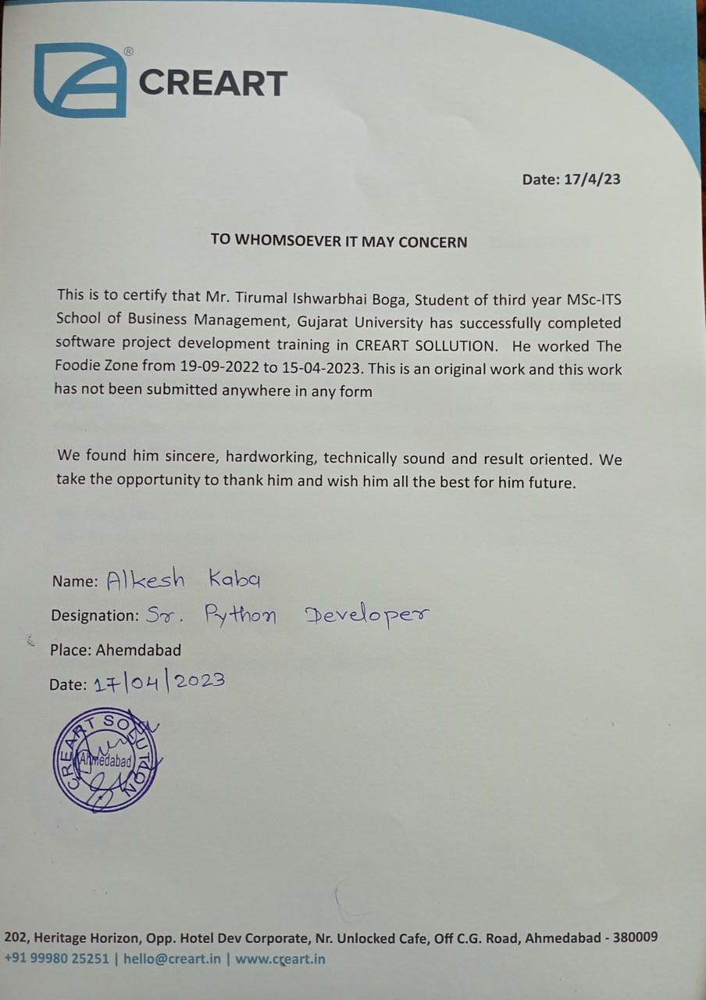

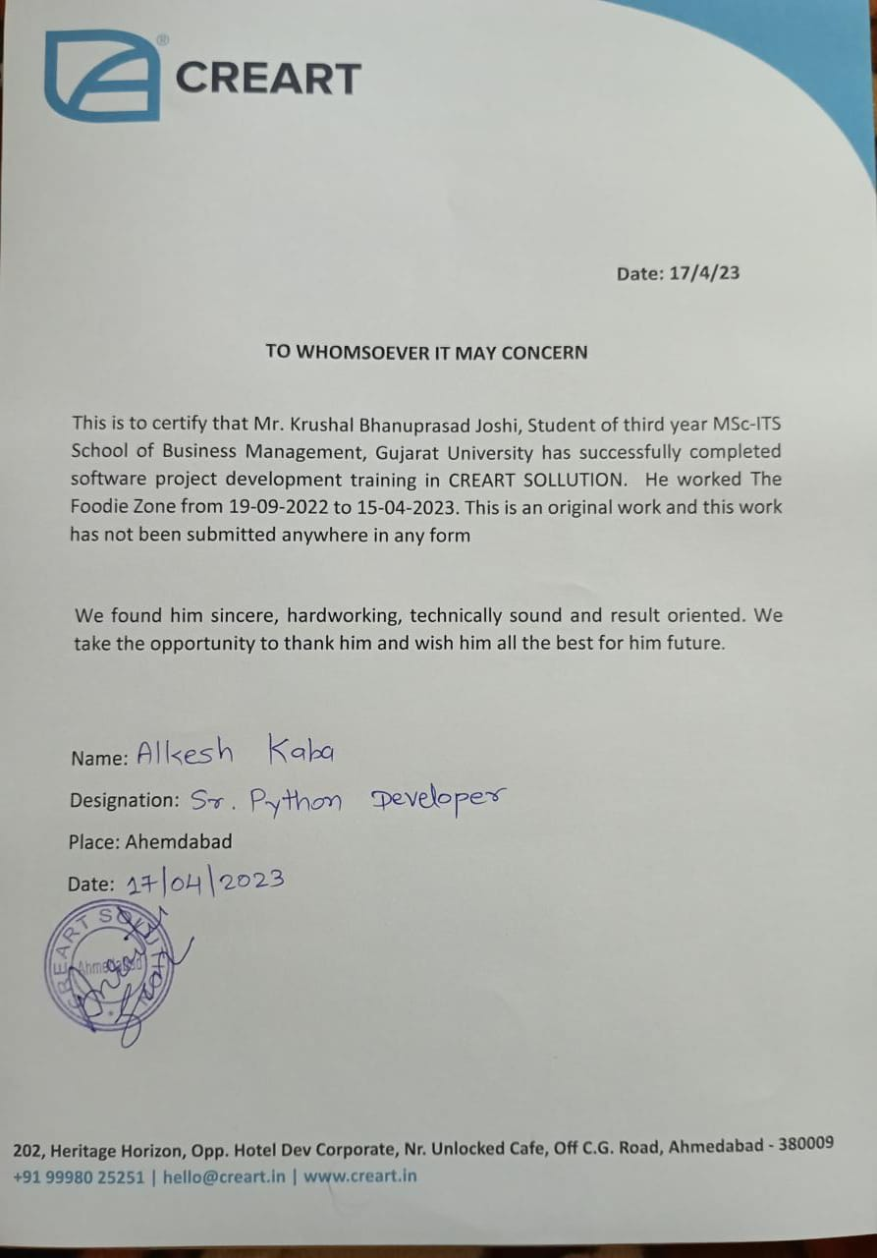

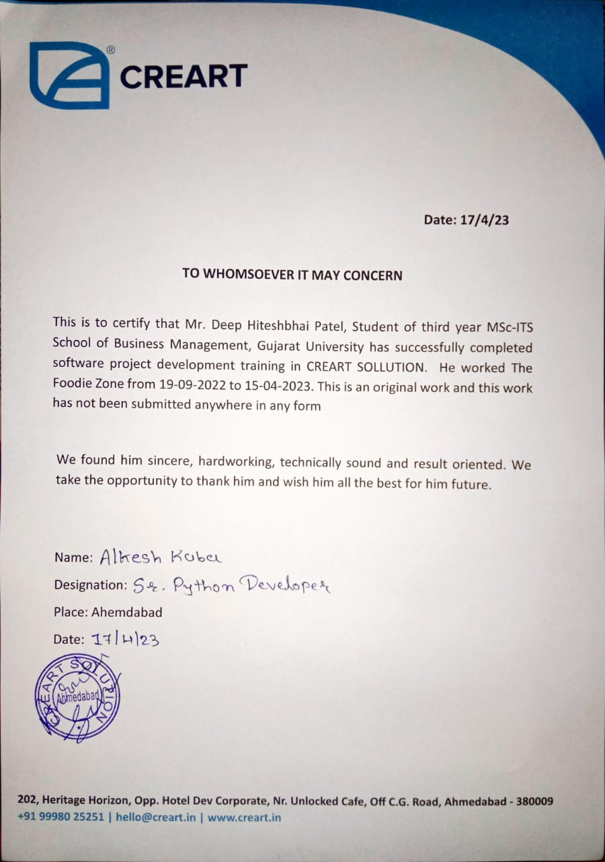

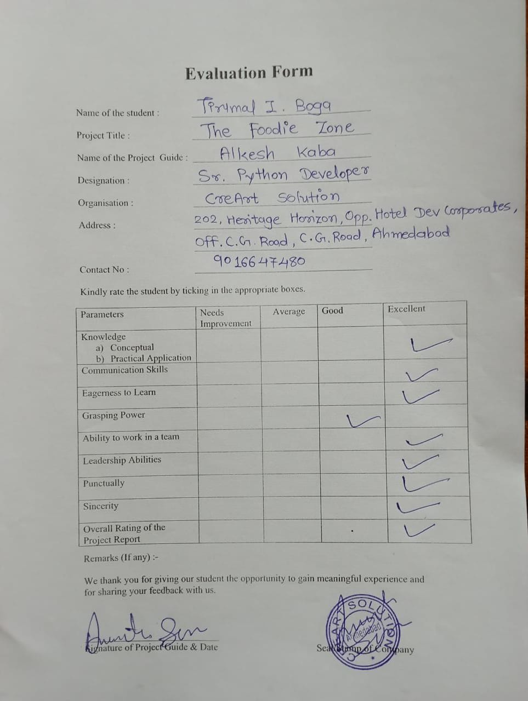

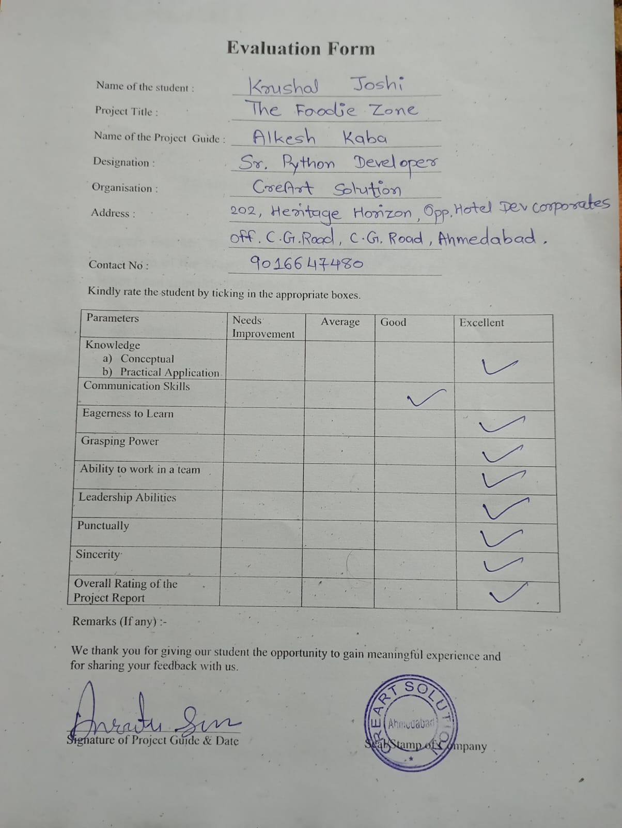

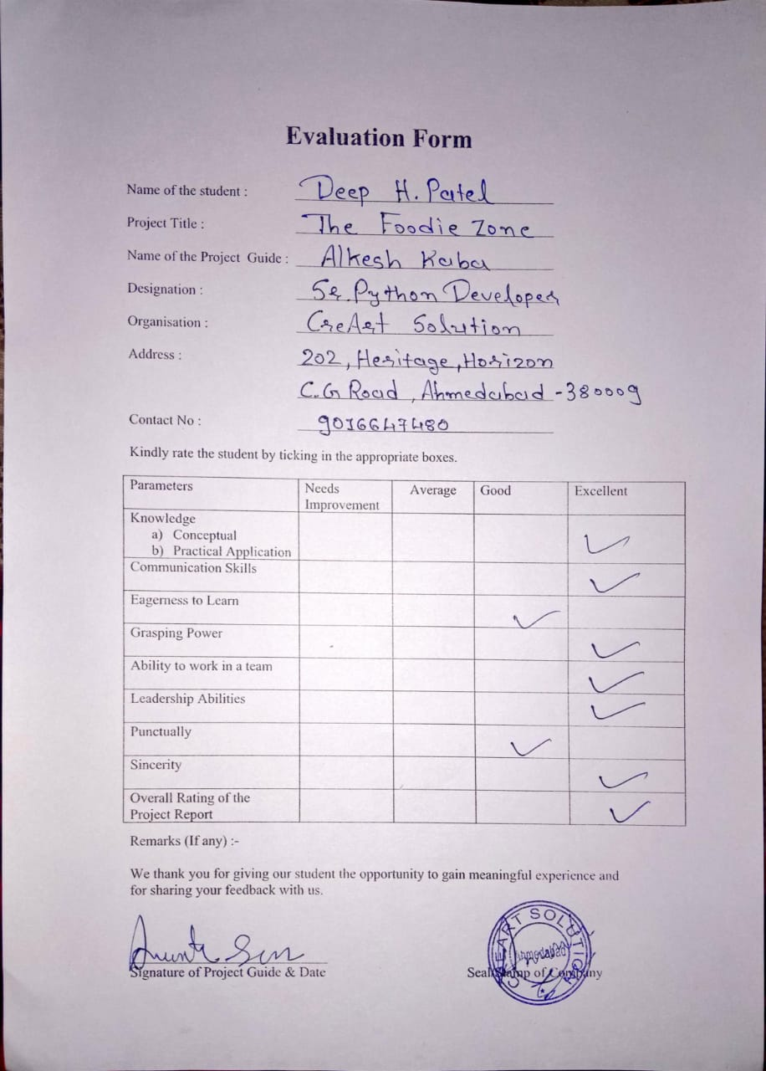

**ACKNOWLEDGEMENT**

I would like to express our thanks to the people who have helped us most throughout our project. We are grateful to our internal guide **DRASHTI SHAH** Ma’am for nonstop support for the project. A special thanks of our goes to the **CreArt Solution** who helped us by providing there support to us. Their continuous help & support made the project much easy. We also express our sincere thanks to all our friends & beneficial who helped us throughout this project.

**INDEX**

Contents

**CHAPTER – 1 INTRODUCTION** 13

**1.1 ORGANIZATION PROFILE** 13

**1.2 SYSTEM DETAILS** 13

**1.2.1 EXISTING SYSTEM** 13

**1.2.2 PROPOSED SYSTEM** 13

**1.3 SCOPE OF SYSTEM** 13

**1.4 OBJECTIVES** 14

**CHAPTER-2 PROPOSED SYSTEM REQUIREMENT GATHERING** 15

**2.1 STACK HOLDER OF THE SYSTEM** 15

**2.2 REQUIREMENT GATHERING TECHNIQUE USED** 15

**2.3 CONSOLIDATED LIST OF REQUIREMENTS** 18

**2.4 PROJECT DEFINITION** 18

**3.1 Feasibility Study** 19

**3.1.1 Technical Study** 19

**3.1.2 Economical Study** 19

**3.1.3 Operational Study** 19

**3.2 Hardware / Software Requirement** 20

➢ Client-Side Requirement: 20

**3.3 System Planning** 21

**3.3.1 Work Breakdown Structure** 21

**3.3.2 Gantt Chart** 22

**3.3.3 Process Model** 23

**CHAPTER-4: SYSTEM ANALYSIS AND DESIGN** 24

**4.1 UML (Unified Modeling Language)** 24

**4.1.1 USE CASE DIAGRAM** 24

**4.1.2 SEQUENCE DIAGRAM** 28

**4.1.3 ACTIVITY DIAGRAM** 31

**4.1.4 CLASS DIAGRAM** 34

**4.2 FLOW CHART** 35

**4.3 DATA DICTIONARY** 36

**4.4 USER INTERFACE** 40

**4.5 SYSTEM NAVIGATION** 54

**CHAPTER-5: INPUT AND OUTPUT DESIGN** 55

**CHAPTER-6: TESTING** 68

**CHAPTER-7: SUMMERY** 72

# **CHAPTER – 1 INTRODUCTION**

## **1.1 ORGANIZATION PROFILE**

CreArt Solutions

Email: [hello@creart.in](mailto:hello@creart.in)

Contact: 9016647480

Contact Person: Alkesh Kaba

Address: 202, Heritage Horizon, Opp. Hotel Dev Corporate, OFF C. G., C. G. Road, Umashankar Joshi Marg, Vasant Vihar, Navrangpura, Ahmedabad, and Gujarat - 380009

## **1.2 SYSTEM DETAILS**

### **1.2.1 EXISTING SYSTEM**

* In the present scenario, people have to physically visit the hotels or restaurants for eating food.
* Through offline Restaurant time as well as physical work is required, among which time is something that no one has in ample amount.
* The traditional food ordering procedure is not efficient enough for hotels and restaurants, as they have to deal with the crowd, in their restaurant.
* Also, from the owner’s point of view maintaining data records and the accounts in the physical file are heavy and difficult work to do.
* And, it is full of risk as anyone can access it and modify the data.

### **1.2.2 PROPOSED SYSTEM**

* Our system enables the end-users to register to the system online, select the food items of their choice from the menu list, and order food online.
* Also, the payment can be made through online mode or at the time of home delivery depending upon the customer’s choice and convenience.
* Online food ordering system is more time-saving and has door to door delivery.
* Online food ordering for customers is that it ensures prices are accurate.

## **1.3 SCOPE OF SYSTEM**

* Our The Foodie Zone project aimed at developing an online food ordering system that can be used in small places, and medium cities firstly and then on a large scale.
* The main purpose of our The Foodie Zone project is to provide customers for a way to place an order at a restaurant over the internet.
* Our system helps restaurants to develop healthy customer relationship by providing good services.
* The system enables restaurants to let update and make changes to their food and beverage list information based on the orders placed and the orders completed.
* It is developed to help restaurants to simplify their daily operational and managerial task.

## **1.4 OBJECTIVES**

* Our website The Foodie Zone will provide easy-to-use online meal ordering for customers.
* It will provide customer to give feedback and view others feedbacks.
* Also, Restaurants can register their self on our website.
* Customer can order their favourite comfort food from the couch with the help of our website.
* Main objective of the system is to give customers the freedom and choice to place an order online any time, from anywhere.

# **CHAPTER-2 PROPOSED SYSTEM REQUIREMENT GATHERING**

## **2.1 STACK HOLDER OF THE SYSTEM**

1. **Admin**

* An admin is responsible for maintaining the system as well as to keep the system running smoothly.
* Admin also manage the functionalities of the system like view users details, manage restaurant,view feedbacks.

1. **Customers**

* Customer is the user of the system which uses the functionalities and services provided by the system.
* A Customer can view food category, give freedom to place an order.
* User can rate and comment on the System.

1. **Sellers/Restaurants**

* Restaurant can register their self, place offer, update food menu.
* Restaurant/Sellers can manage food items.
* Restaurant/Sellers can see feedback of Customer

## **2.2 REQUIREMENT GATHERING TECHNIQUE USED**

We used Interview technique for gathering the requirements.

Interview Q/A of Stakeholders:

1. **Admin**

**Q.1. Do you have basic knowledge of IT?**

Ans. Yes

**Q.2. Do you understand your role as an admin?**

Ans. Yes

**Q.3. Will you able to fix minor issues related to the website by yourself?**

Ans. Yes

**Q.4. Have you ever managed some system like this before?**

Ans. No

**Q.5. If sometimes any restaurant is stuck with any problem or don’t understand something regarding the system, will you help them out or not?**

Ans. Yes

**Q.6. Will you generate the report periodically?**

Ans. Yes

**Q.7. Will you collect the analytics?**

Ans. Yes

**Q.8. Will you be able to manage food items category, restaurants, users, and food orders.**

Ans. Yes

**Q.9. Are you going to manage feedback?**

Ans. Yes

**Q.10. How you will be managing our system? Explain in details.**

Ans. I’ll manage the food items category, view restaurants details, view users details, food orders, view feedbacks will also be managed. If some kind of some problem occurs into the system related to any entity, than I will solve that problem as soon as possible.

1. **Customers**

**Q.1. How do you find our idea of getting food at any place on the single webpage?**

Ans. Good idea as well get more options to order food.

**Q.2. Will you relay on our system for getting the above-mentioned things done?**

Ans. Yes

**Q.3. Do you prefer online mode of payment?**

Ans. Yes

**Q.4. Will you opt for getting the online food?**

Ans. Yes it would save a lot of time.

**Q.5. What features or kind of look you would prefer in our system?**

Ans. System should have friendly navigation and easy to use.

**Q.6. what do you know about online system?**

Ans. We have visited some food ordering sites so we know about the basic functionality of them.

**Q.7. System should be attractive or user friendly or both?**

Ans. Both

**Q.8. Would you rather prefer online or offline system?**

Ans. Online System for getting things done fast.

**Q.9. Would you like to share the feedback of our services which you used?**

Ans. Yes

**Q.10. Would you recommend our system to others if you like it?**

Ans. Yes

**Q.11. which features do you appreciate in our system?**

Ans. Getting variety of food without visiting the restaurants physically generally.

1. **Sellers/Restaurants**

**Q.1. Describe your target audience.**

Ans. Our target audience is going to be the people who are in need of online food services.

**Q.2. what goals do you want to achieve through this system?**

Ans. Major Goal is to sell our food with the customers who wants to order food online and through online food the time of clients as well as of ours will be saved.

**Q.3. what makes you different from your competitors?**

Ans. The way we provide good quality foods to the customers.

**Q.4. what functions do you need in system?**

Ans. Functions like Managing offer, different category of food, view customer feedback for our product, customers can make the payment online and offline.

**Q.5. From which mode of payments would you like to receive payment?**

Ans. Online payment will be preferable.

**Q.6. Do you want your clients to provide a feedback on your restaurant services?**

Ans. Yes.

**Q.7. Do you currently have a website? If so, what is/isn’t working for you?**

Ans. No.

**Q.8. Who is your ideal customer?**

Ans. Looking for the food with less time duration.

**Q.9. so, are there any colour preferences for the system?**

Ans. The system should look professional.

## **2.3 CONSOLIDATED LIST OF REQUIREMENTS**

* For making it easy to get food at any place for customer where they will get different category of foods.
* Customer can get the food services they are in need of.
* Customer can pay for the services through online and offline payment option.
* They can also provide their valuable feedback for the system services.
* Admin can also view the payment status and feedback provided by the client.
* Admin can view details of users and manage restaurants.
* Restaurants can manage orders of food items and offers on food items.
* Restaurant can see feedback of the customer.

## **2.4 PROJECT DEFINITION**

* Our website The Foodie Zone (clone of Zomato) will provide easy-to-use online meal ordering for customers.
* It will provide customer to give feedback and also view other feedbacks.
* Due to our system user can save lot of time.

**CHAPTER-3: SYSTEM MANAGEMENT AND PLANNING**

## **3.1 Feasibility Study**

The feasibility study is an important phase during the development of any project, its goal is to determine whether the project is doable or not. Our capstone project is about building a web application, which purpose is to help people in choosing their favourite food from nearby restaurants. Feasibility of a new system means ensuring that the new system, which we are going to implement is efficient. There are various types of feasibility to be determined. They are:

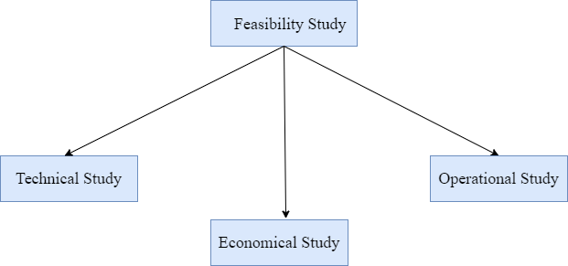

### **3.1.1 Technical Study**

First, the technical feasibility is to understand if it is possible to complete the project with the current technologies. This application is going to use many programming languages and frameworks in order to ensure a good user experience for the end user. The structure of the application will consist of a backend and a frontend.

* The Foodie Zone food ordering system is a web-based application. The main technologies and tools which are going to be use are as follows:
* HTML
* CSS
* Bootstrap
* Python
* Django
* MYSQL
* Diagram Drawing Tools: - Draw.io

### **3.1.2 Economical Study**

* Second, the economic feasibility is essential to know the budget needed for the completion of the application, and how much income it would be able to generate once released. The necessary budget for this project is low, the technologies needed for this project are free to use.
* The System will follow the freeware standards. No cost will be charged from the potential customers.
* Relatively there is no cost associated in managing the system once it is developed.
* No special hardware integration is required by the system.
* So, it is very much clear that our system is economically feasible.

### 3.1.3 Operational Study

Operational feasibility is the measure of how well a proposed system solves the problems and takes advantage of the opportunities identified during scope definition and how it satisfies the requirements identified in the requirements analysis phase of system development.

* Determines whether the problems anticipated in user requirements are of high priority.
* Analyses whether users will adapt to a new software.
* Our system will be easy to use and much secured.

## 3.2 Hardware / Software Requirement

* Server-Side Requirement:
* Software Requirement:

|  |  |
| --- | --- |
| Frontend | HTML, CSS, Bootstrap, Python |
| Backend | MySQL |
| Tools | Sublime Text |

* Hardware Requirement:

|  |  |
| --- | --- |
| RAM | 2GB or Higher |
| Hard Disk | 1GB or Higher |
| Processor | Core i3 or Higher |

* Client-Side Requirement:
* Software Requirement:

|  |  |
| --- | --- |
| OS | Minimum Windows 8 or Higher |
| Browser | Mozilla v65.0.2 or Chrome v73.0.3683.86 |

* Hardware Requirement:

|  |  |
| --- | --- |
| RAM | 2GB or Higher |
| Hard Disk | 1GB or Higher |
| Processor | Core i3 or Higher |

## **3.3 System Planning**

### 3.3.1 Work Breakdown Structure

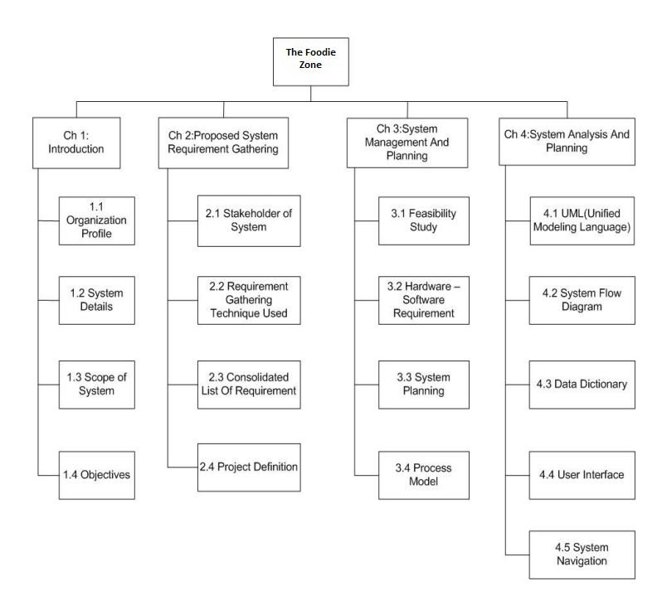

### 3.3.2 Gantt Chart

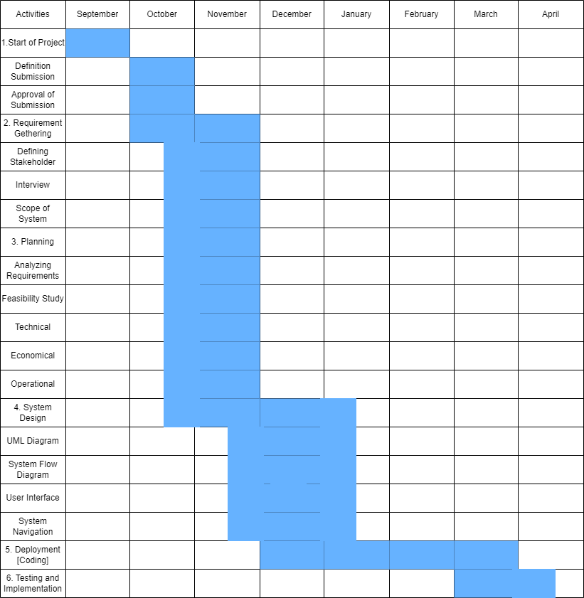

### 3.3.3 Process Model

Incremental Model:

* When initial requirements are reasonably well defined, and the overall scope of the development effort prevents a purely linear process. A need to expand a limited set of new functions to a later system release.
* It combines elements of linear and parallel process flows. Each linear sequence produces deliverable increments of the software.
* The first increment is often a core product with many supplementary features. Users use it and evaluate it with more modifications to better meet the needs.
* Suited for large projects, less expensive to the change of requirements as they support customer interactions with each increment.
* Initial versions of the software are produced early, which facilitates customer evaluation and feedback.
* It doesn’t fit into small projects, or projects that waterfall are best suited for; A structured process with a detailed, and accurate description of the system.

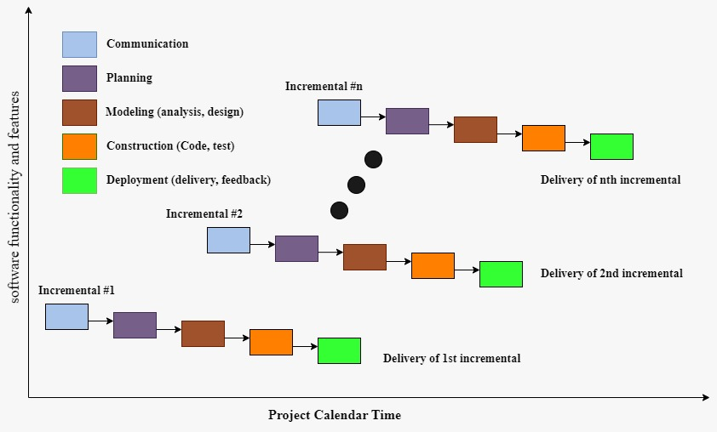

# **CHAPTER-4: SYSTEM ANALYSIS AND DESIGN**

## **4.1 UML (Unified Modeling Language)**

### **4.1.1 USE CASE DIAGRAM**

**1. Admin**

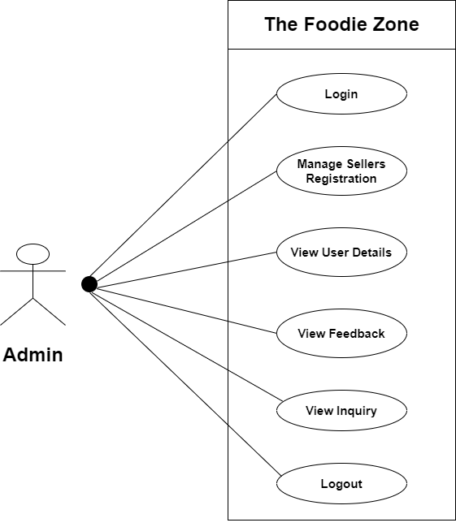

**2. Customer**

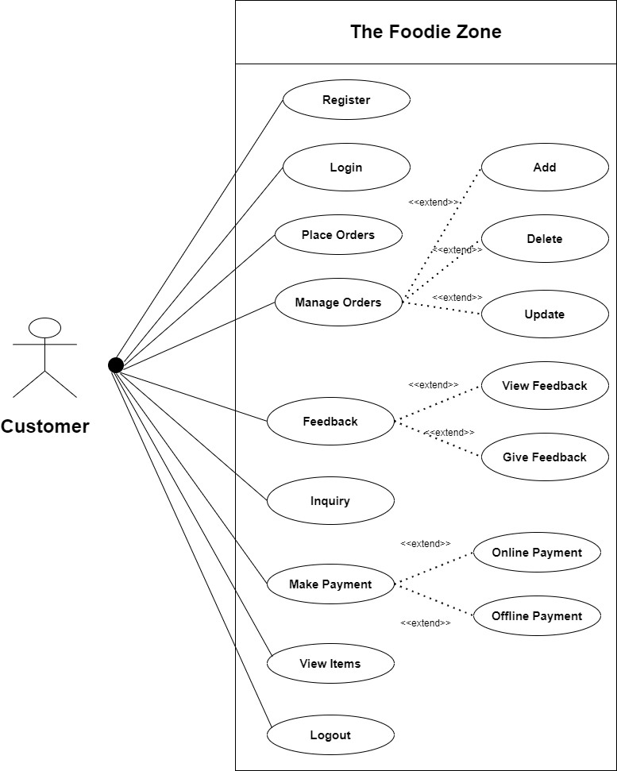

**3. Seller**

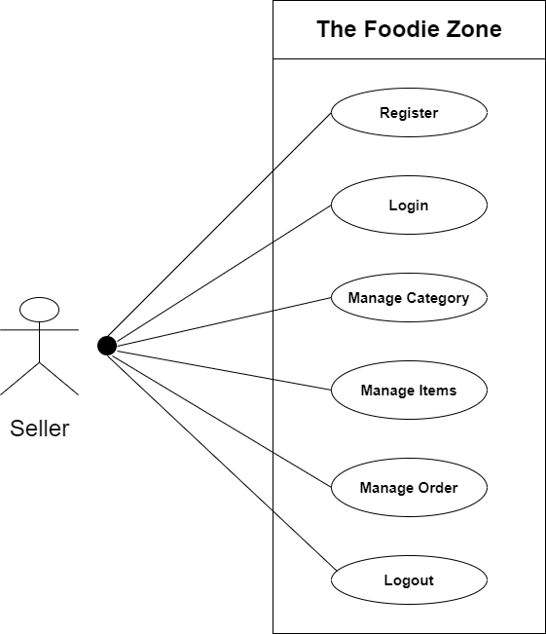

1. **Usecase Diagram (3 in 1):**

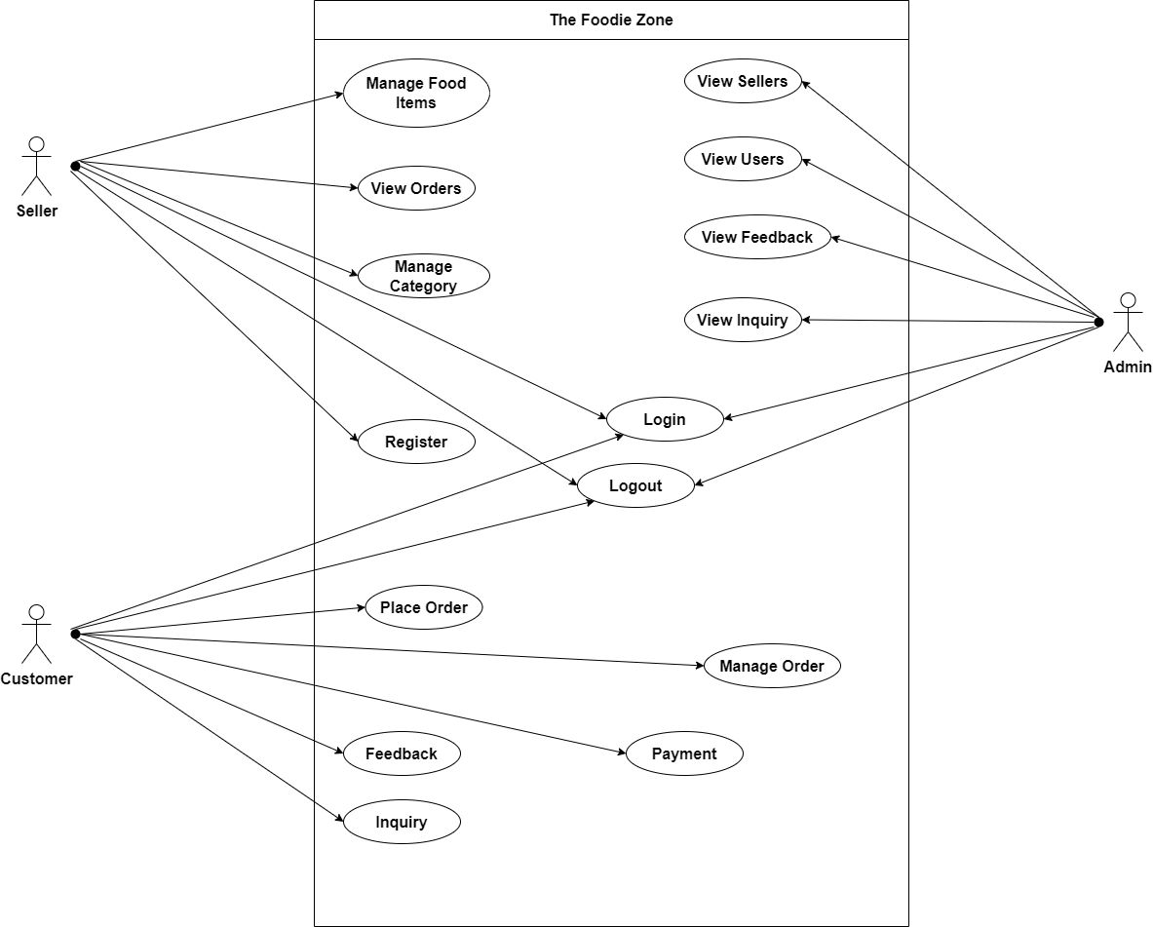

### **4.1.2 SEQUENCE DIAGRAM**

**1. Admin**

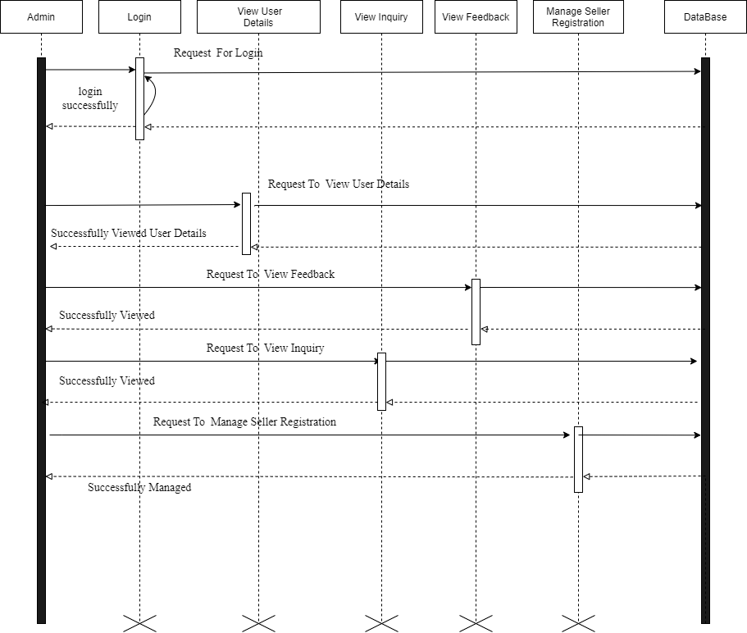

**2. Customer**

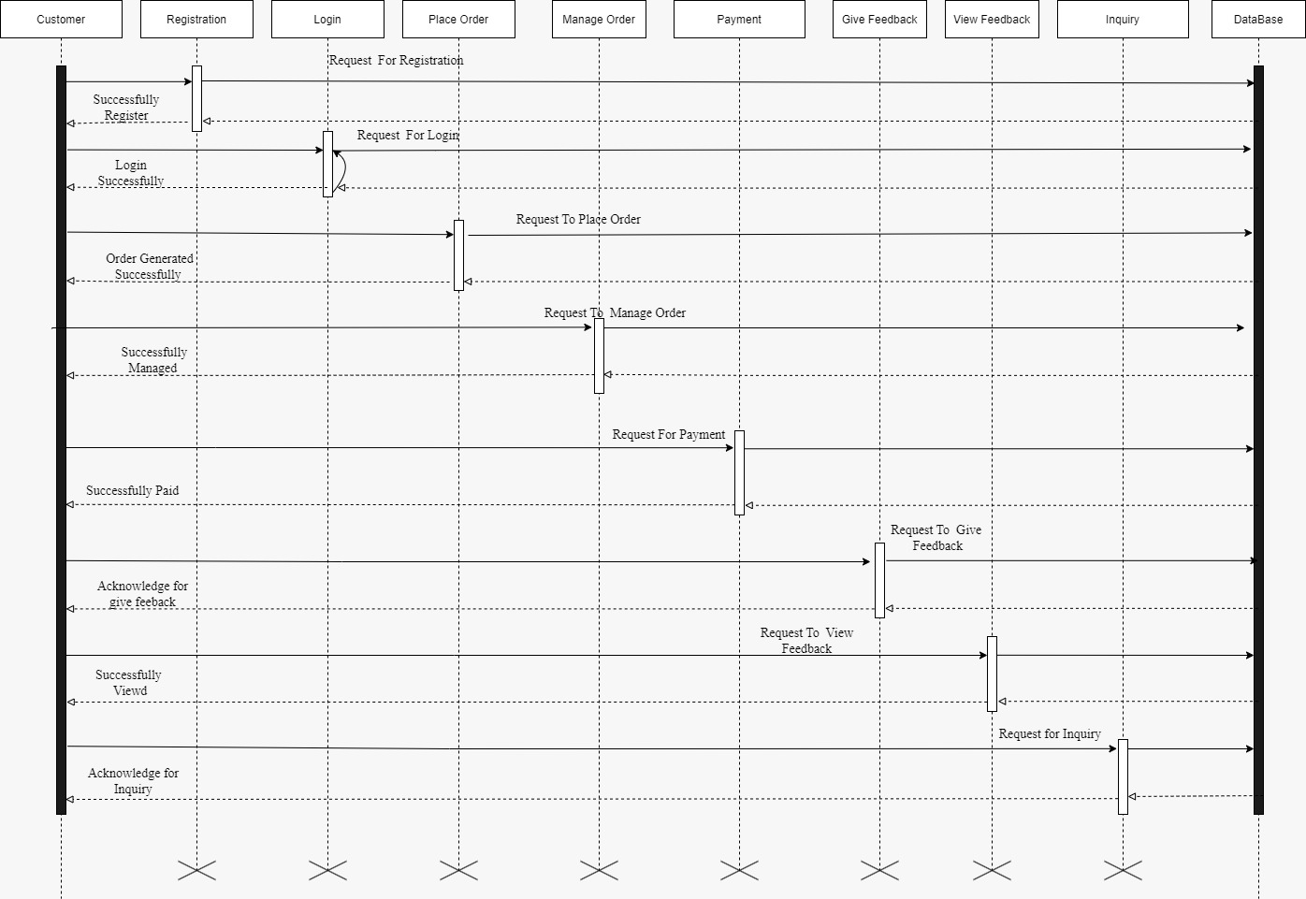

**3. Seller**

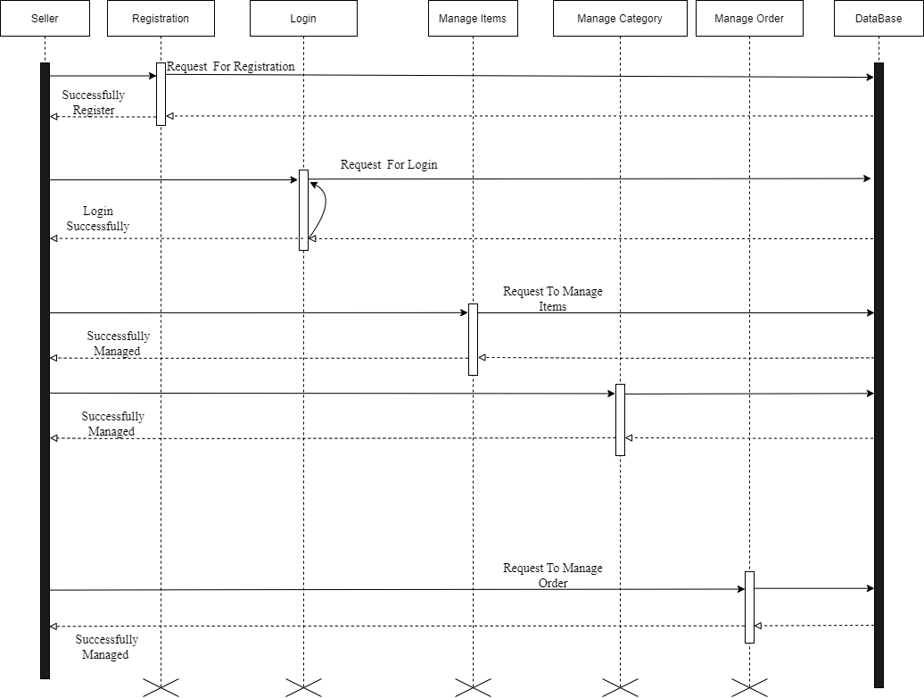

### **4.1.3 ACTIVITY DIAGRAM**

**1. Admin**

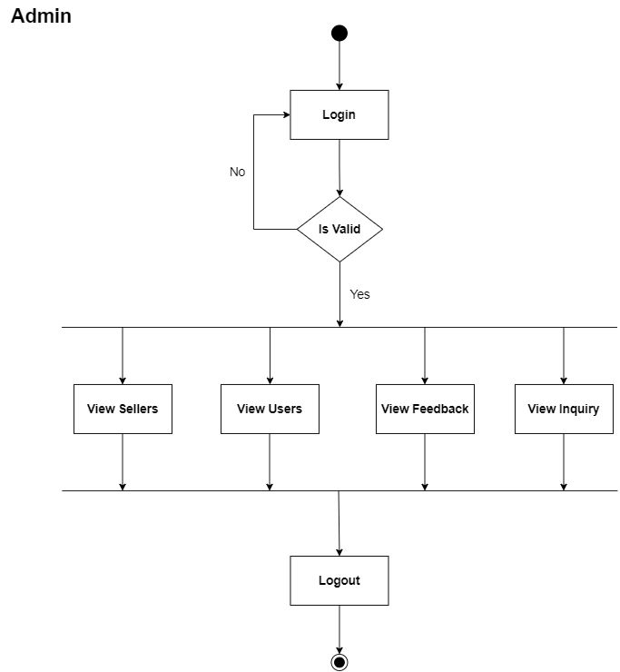

**2. Customer**

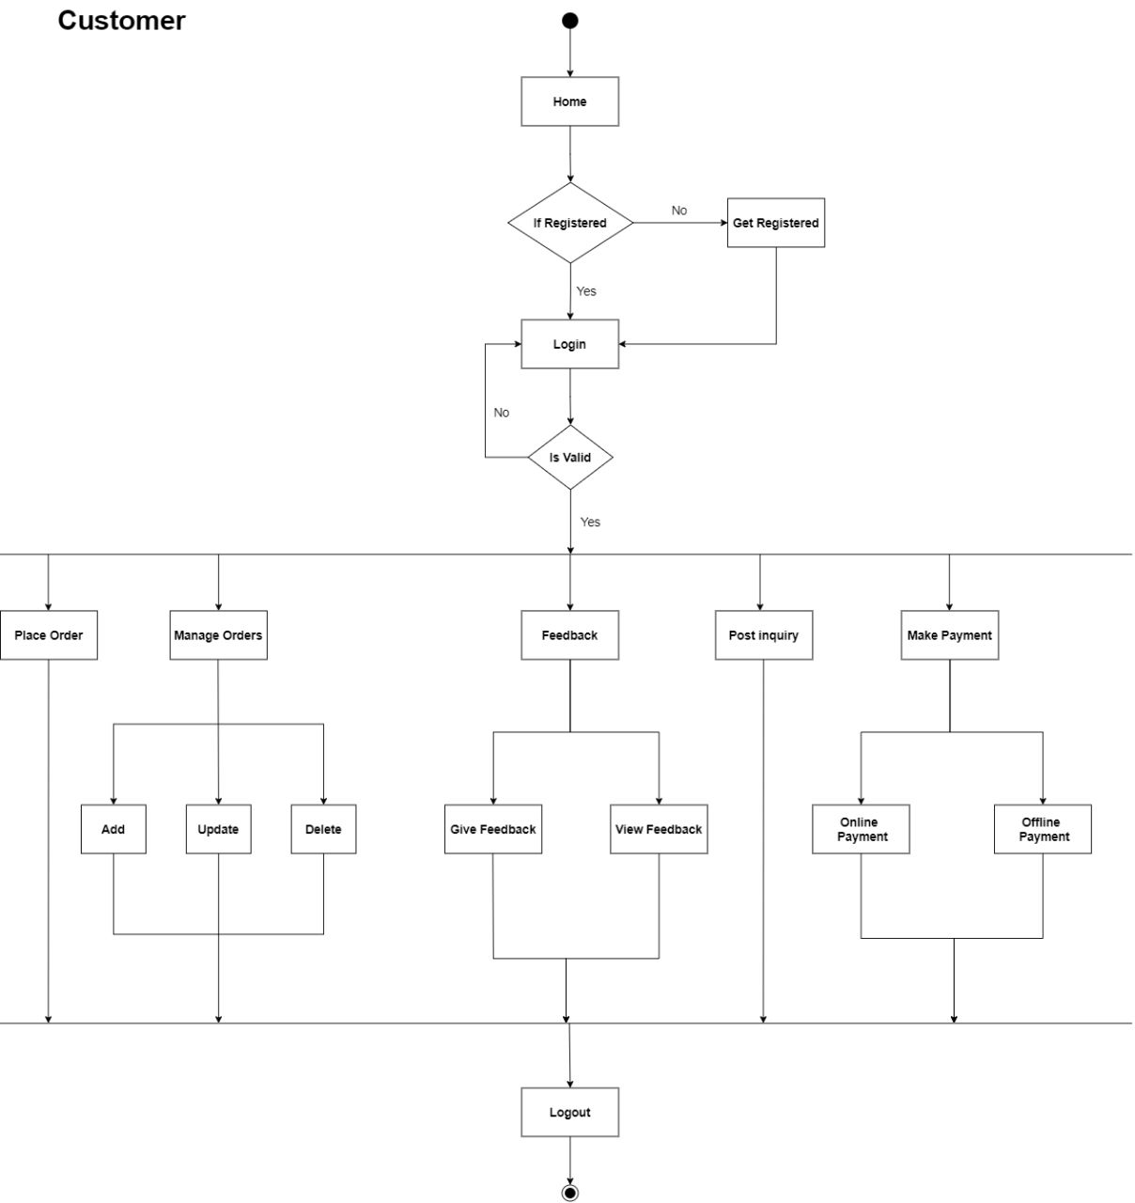

**3. Seller**

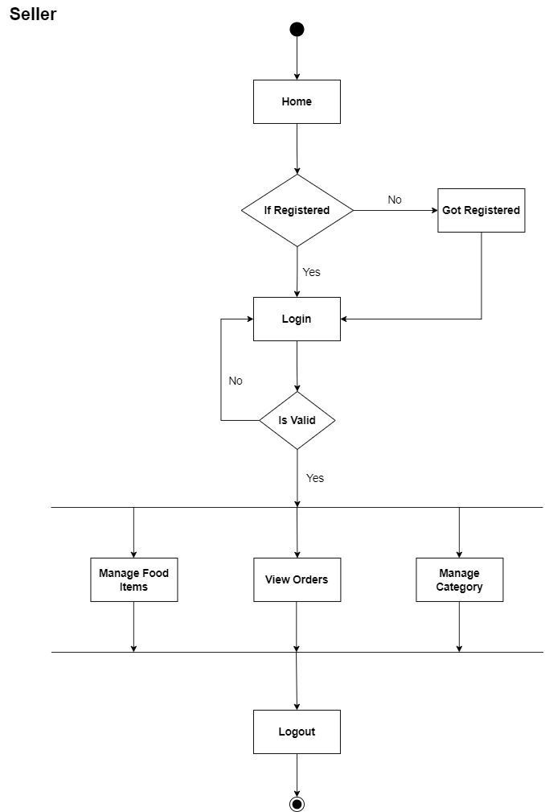

### **4.1.4 CLASS DIAGRAM**

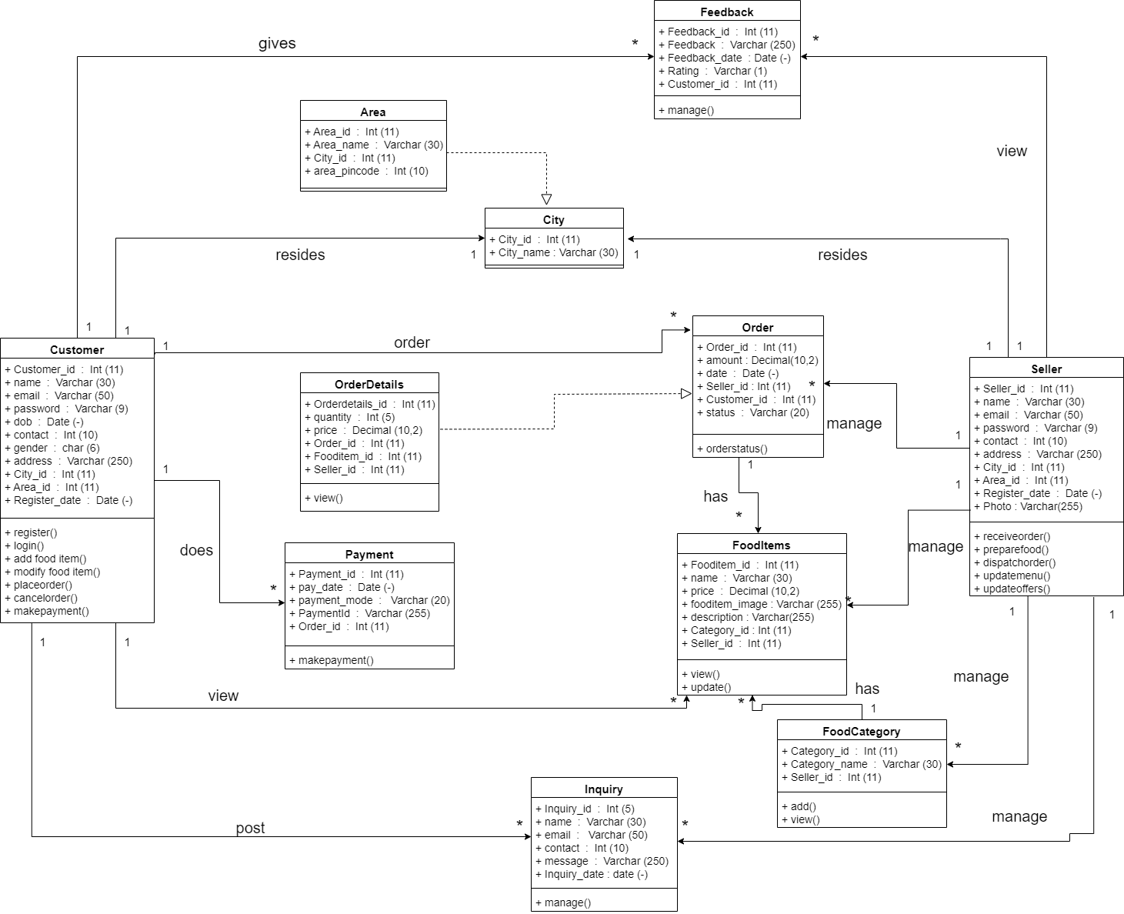

## **4.2 FLOW CHART**

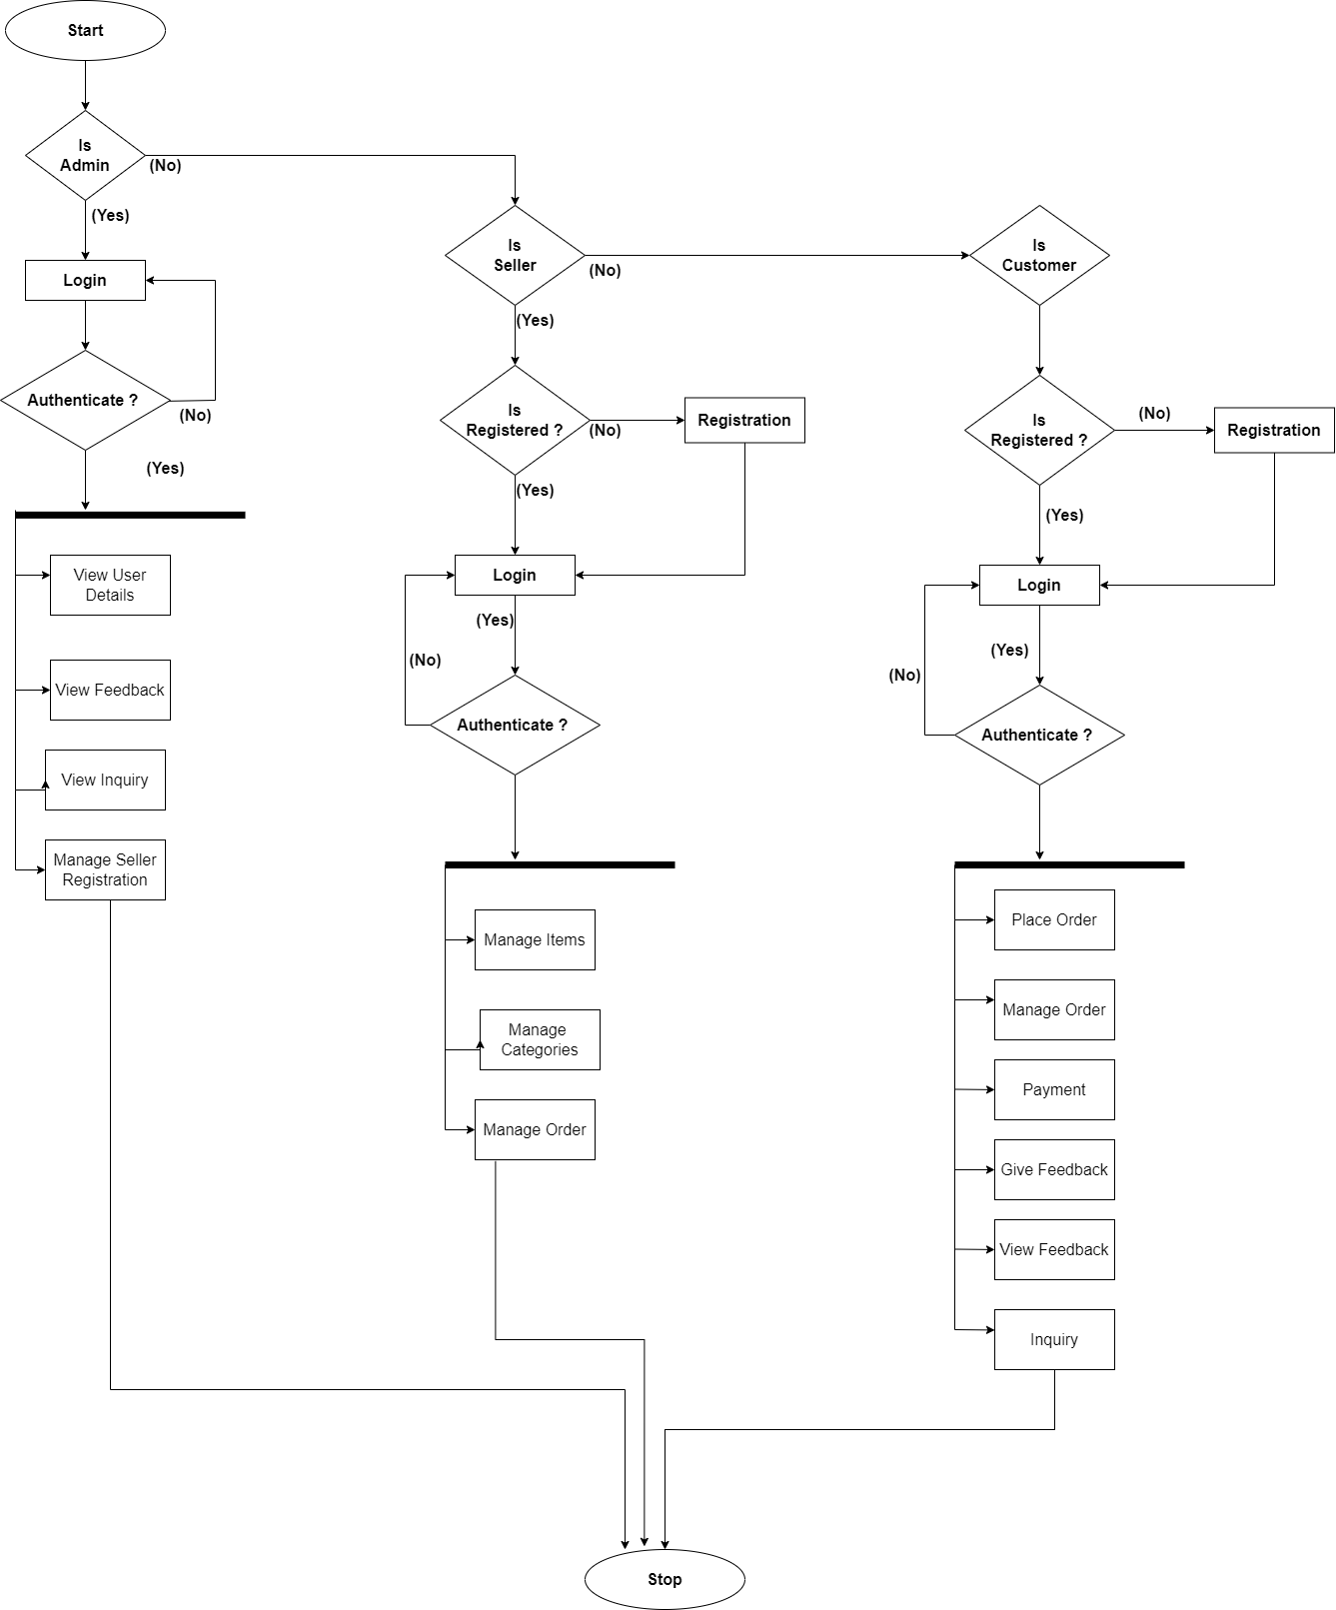

## **4.3 DATA DICTIONARY**

**Total Tables:-**

1. Customer
2. Seller
3. City
4. Area
5. Food-Category
6. Food-item
7. Order
8. Order-details
9. Payment
10. Feedback
11. Inquiry
12. **Table Name: Customer**

|  |  |  |  |  |  |
| --- | --- | --- | --- | --- | --- |
| Sr. No. | Field_Name | Data Types | Size | Constraint | Description |
| 1 | Customer_id | Big Int | 11 | Primary key | Customer id |
| 2 | Name | Varchar | 30 | Not null | Customer name |
| 3 | Email | Varchar | 50 | Unique | Email id |
| 4 | Password | Varchar | 9 | Not null | password |
| 5 | DOB | Date | - | Not null | Date of birth |
| 6 | Contact | Big Int | 10 | Unique | Contact number |
| 7 | Gender | Varchar | 6 | Not null | Gender |
| 8 | Address | Varchar | 250 | Not null | address |
| 9 | City_id | Big Int | 11 | Foreign key | Foreign key  form city table |
| 10 | Area_id | Big Int | 11 | Foreign key | Foreign key  from area table |
| 11 | Register_date | Date | - | Not null | Register date |

1. **Table Name: Seller**

|  |  |  |  |  |  |
| --- | --- | --- | --- | --- | --- |
| Sr. No. | Field_Name | Data Types | Size | Constraint | Description |
| 1 | Seller_id | Big Int | 11 | Primary key | Seller id |
| 2 | Name | Varchar | 30 | Not null | Seller name |
| 3 | Email | Varchar | 50 | Not null | Email id |
| 4 | Password | Varchar | 9 | Not null | password |
| 5 | con C Contact | Big Int | 10 | Unique | Contact no |
| 6 | Address | Varchar | 250 | Not null | Address |
| 7 | Photo | Varchar | 255 | Not null | Restaurent Image |
| 8 | City_id | Big Int | 11 | Foreign key | Foreign key Form  City table |
| 9 | Area_id | Big Int | 11 | Foreign key | Foreign key From  Area table |
| 10 | Register_date | Date | - | Not null | Register date |

1. **Table Name: City**

|  |  |  |  |  |  |
| --- | --- | --- | --- | --- | --- |
| Sr. No. | Field_Name | Data Types | Size | Constraint | Description |
| 1 | City_id | Big Int | 11 | Primary key | City id |
| 2 | City_name | Varchar | 30 | Not null | City name |

1. **Table Name: Area**

|  |  |  |  |  |  |
| --- | --- | --- | --- | --- | --- |
| Sr. No. | Field_Name | Data Types | Size | Constraint | Description |
| 1 | Area_id | Big Int | 11 | Primary key | Area id |
| 2 | Area_name | Varchar | 30 | Not null | Area name |
| 3 | City_id | Big Int | 11 | Foreign key | Foreign key  From city table |
| 4 | Area_pincode | Big Int | 10 | Not null | Area’s Pincode |

1. **Table Name: Food-Category**

|  |  |  |  |  |  |
| --- | --- | --- | --- | --- | --- |
| Sr. No. | Field_Name | Data Types | Size | Constraint | Description |
| 1 | Category_id | Big Int | 11 | Primary key | Category id |
| 2 | Category_name | Varchar | 30 | Not null | Category  name |
| 3 | Seller_id | Big Int | 11 | Foreign key | Foreign key From  Seller table |

1. **Table Name: Food-items**

|  |  |  |  |  |  |
| --- | --- | --- | --- | --- | --- |
| Sr. No. | Field_Name | Data Types | Size | Constraint | Description |
| 1 | Fooditem_id | Big Int | 11 | Primary key | Fooditem id |
| 2 | Name | Varchar | 30 | Not null | Category name |
| 3 | Price | Decimal | 10,2 | Not null | Food item Price |
| 4 | Fooditem_  image | Varchar | 255 | Not null | Path of image of food  item (if available |
| 5 | Description | Text | - | Not null | Description of Food Items |
| 6 | Category_id | Big Int | 11 | Foreign key | Foreign key From  Category table |
| 7 | Seller_id | Big Int | 11 | Foreign key | Foreign key From  Seller table |

1. **Table Name: Order**

|  |  |  |  |  |  |
| --- | --- | --- | --- | --- | --- |
| Sr. No. | Field_Name | Data Types | Size | Constraint | Description |
| 1 | Order_id | Big Int | 11 | Primary key | Order id |
| 2 | Amount | Decimal | 10,2 | Not null | Order Amount |
| 3 | Date | Date | - | Not null | Order date |
| 4 | Seller_id | Bif Int | 11 | Foreign key | Foreign key From  Seller table |
| 5 | Customer_id | Big Int | 11 | Foreign key | Foreign key From  Customer table |
| 6 | Status | Varchar | 20 | Not null | Order Status |

1. **Table Name: Order_details**

|  |  |  |  |  |  |
| --- | --- | --- | --- | --- | --- |
| Sr. No. | Field_Name | Data Types | Size | Constraint | Description |
| 1 | Orderdetails  _id | Big Int | 11 | Primary key | Orderdetails id |
| 2 | Quantity | Int | 5 | Not null | Item quantity |
| 3 | Price | Decimal | 10,2 | Not null | Food Price |
| 4 | Order_id | Big Int | 11 | Foreign key | Foreign key From  Order table |
| 5 | Fooditem_id | Big Int | 11 | Foreign key | Foreign key From  Fooditem table |
| 6 | Seller_id | Big Int | 11 | Foreign key | Foreign key From  Seller table |

1. **Table Name: Payment**

|  |  |  |  |  |  |
| --- | --- | --- | --- | --- | --- |
| Sr. No. | Field_Name | Data Types | Size | Constraint | Description |
| 1 | Payment_id | Big Int | 11 | Primary key | Payment id |
| 2 | Pay_date | Date | - | Not null | Payment date |
| 3 | Payment_mode | Varchar | 20 | Not null | Shows Payment mode |
| 4 | PaymentId | Varchar | 255 | Not null | Shows UPI id |
| 5 | Order_id | Big Int | 11 | Foreign key | Foreign key from  Order table |

1. **Table Name: Feedback**

|  |  |  |  |  |  |
| --- | --- | --- | --- | --- | --- |
| Sr. No. | Field_Name | Data Types | Size | Constraint | Description |
| 1 | Feedback_id | Big Int | 11 | Primary key | Feedback id |
| 2 | Feedback | Text | - | Not null | Actual Feedback |
| 3 | Feedback  date | Date | - | Not null | Date on which feedback was given |
| 4 | Rating | Int | 1 | Not null | User rating (start  out of five)  1 – poor  2 – ok  3 – Good  4 – Satisfied  5 – Very Satisfied |
| 5 | Customer_id | Big Int | 11 | Foreign key | Foreign key from  Customer table |

1. **Table Name: Inquiry**

|  |  |  |  |  |  |
| --- | --- | --- | --- | --- | --- |
| Sr. No. | Field_Name | Data Types | Size | Constraint | Description |
| 1 | Inquiry_id | Big Int | 11 | Primary key | Inquiry id |
| 2 | Name | Varchar | 30 | Not null | Inquire name |
| 4 | Email | Varchar | 50 | Not null | Inquire email |
| 5 | Contact | Big Int | 10 | Not null | Inquire contact no |
| 6 | Message | Text | - | Not null | Shows actual  message |
| 7 | Inquiry_date | Date | - | Not null | Shows inquiry  date |

## **4.4 USER INTERFACE**

* **User Home Page:**

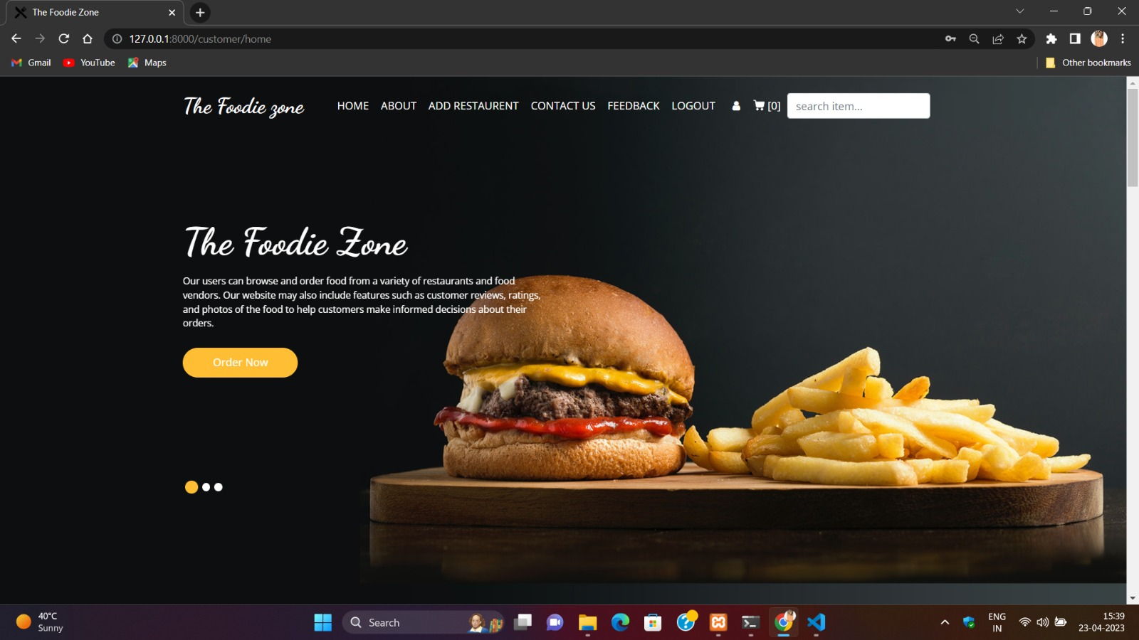

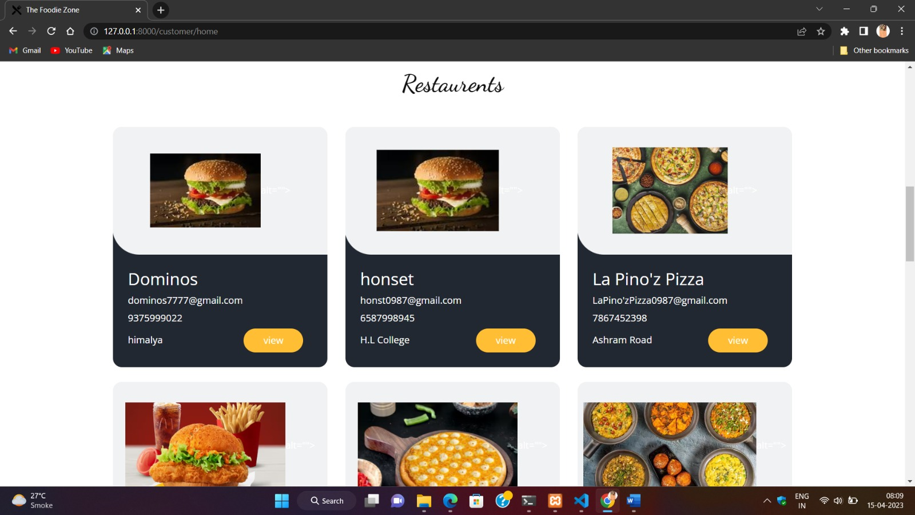

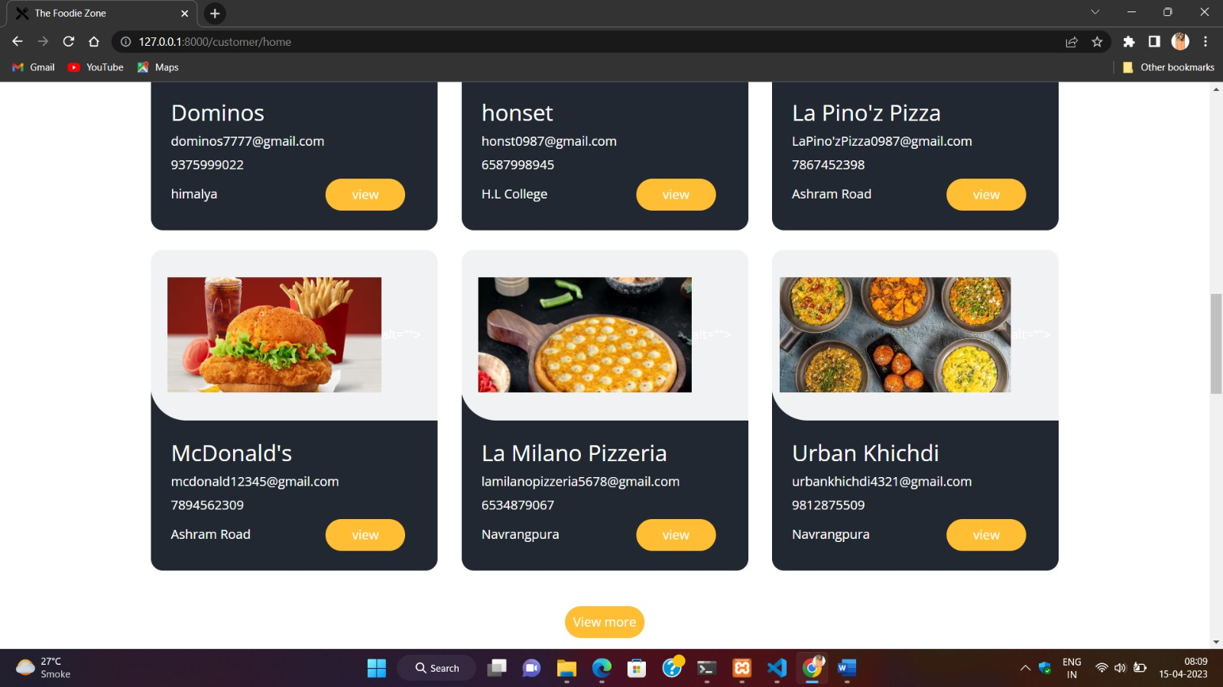

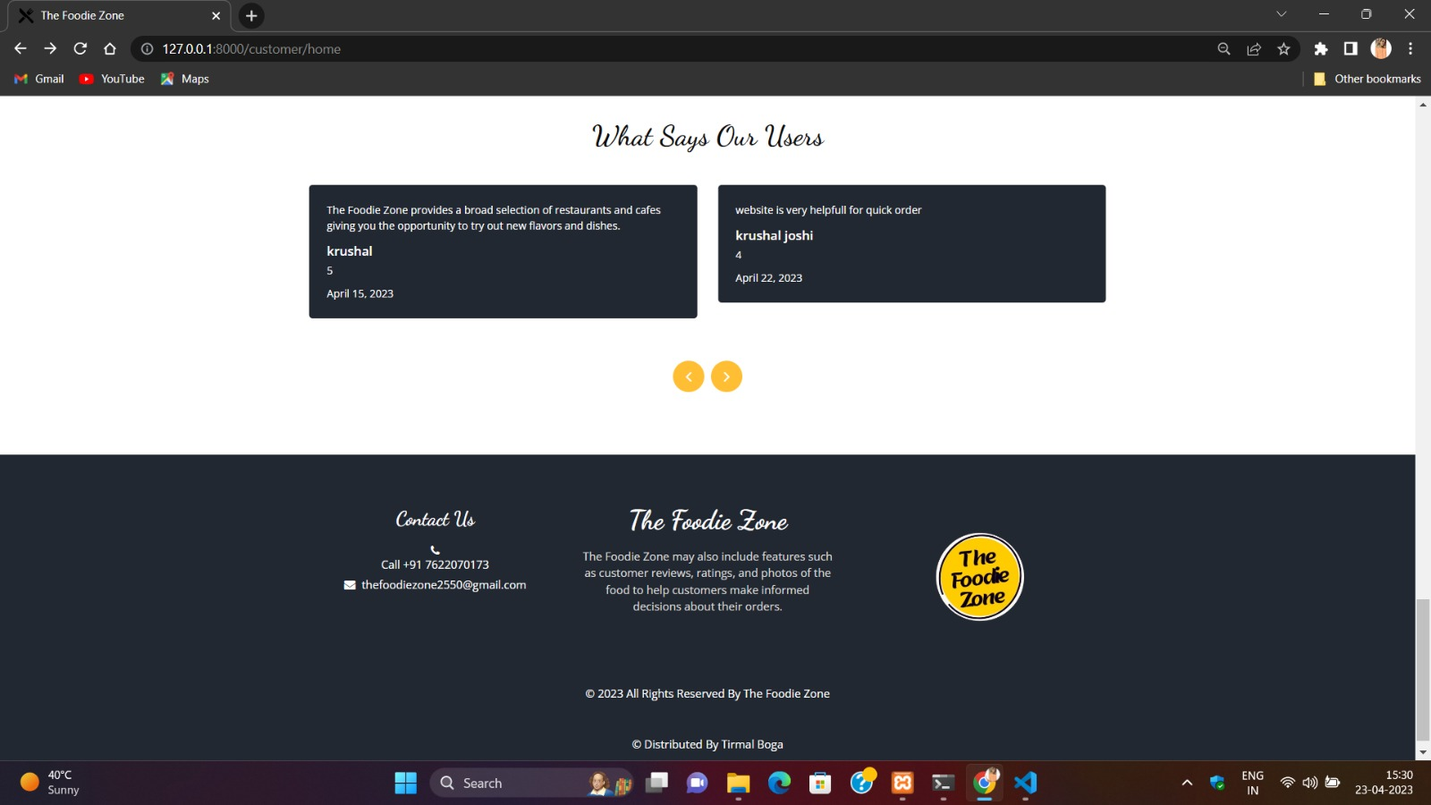

* **User Profile:**

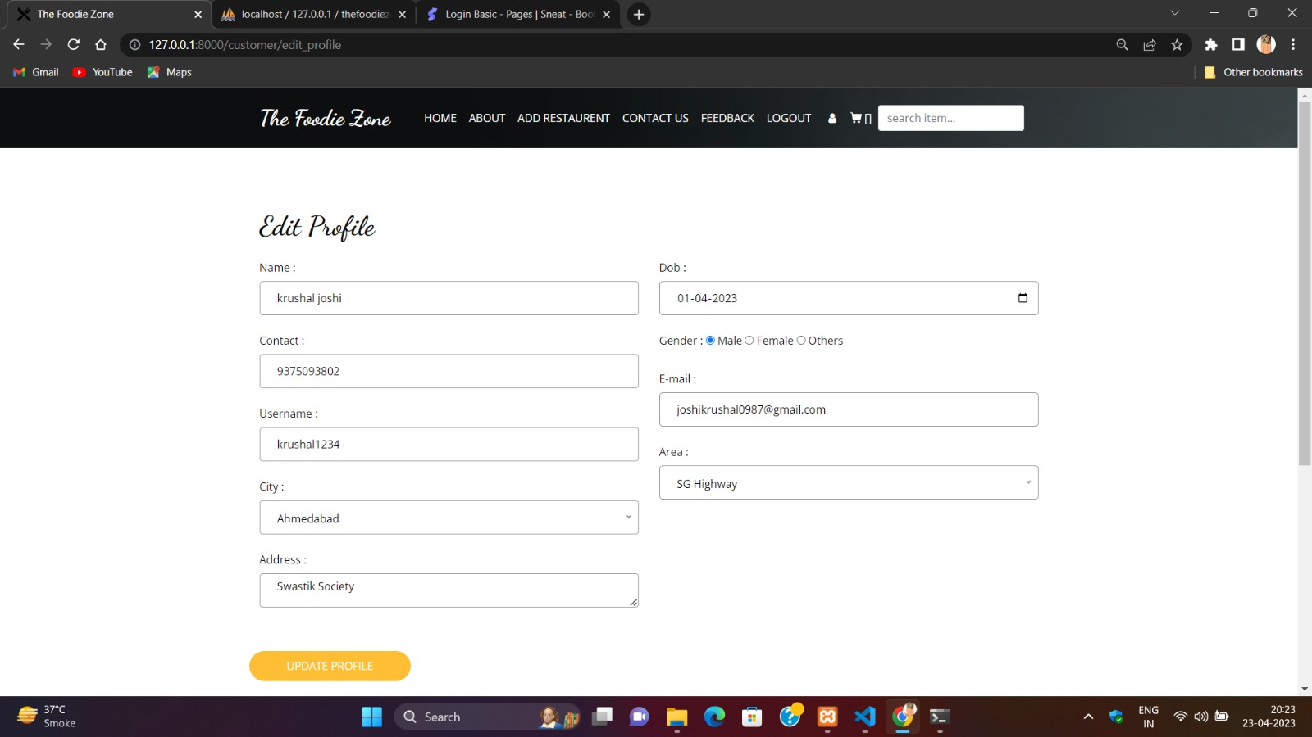

* **Food Item Page:**

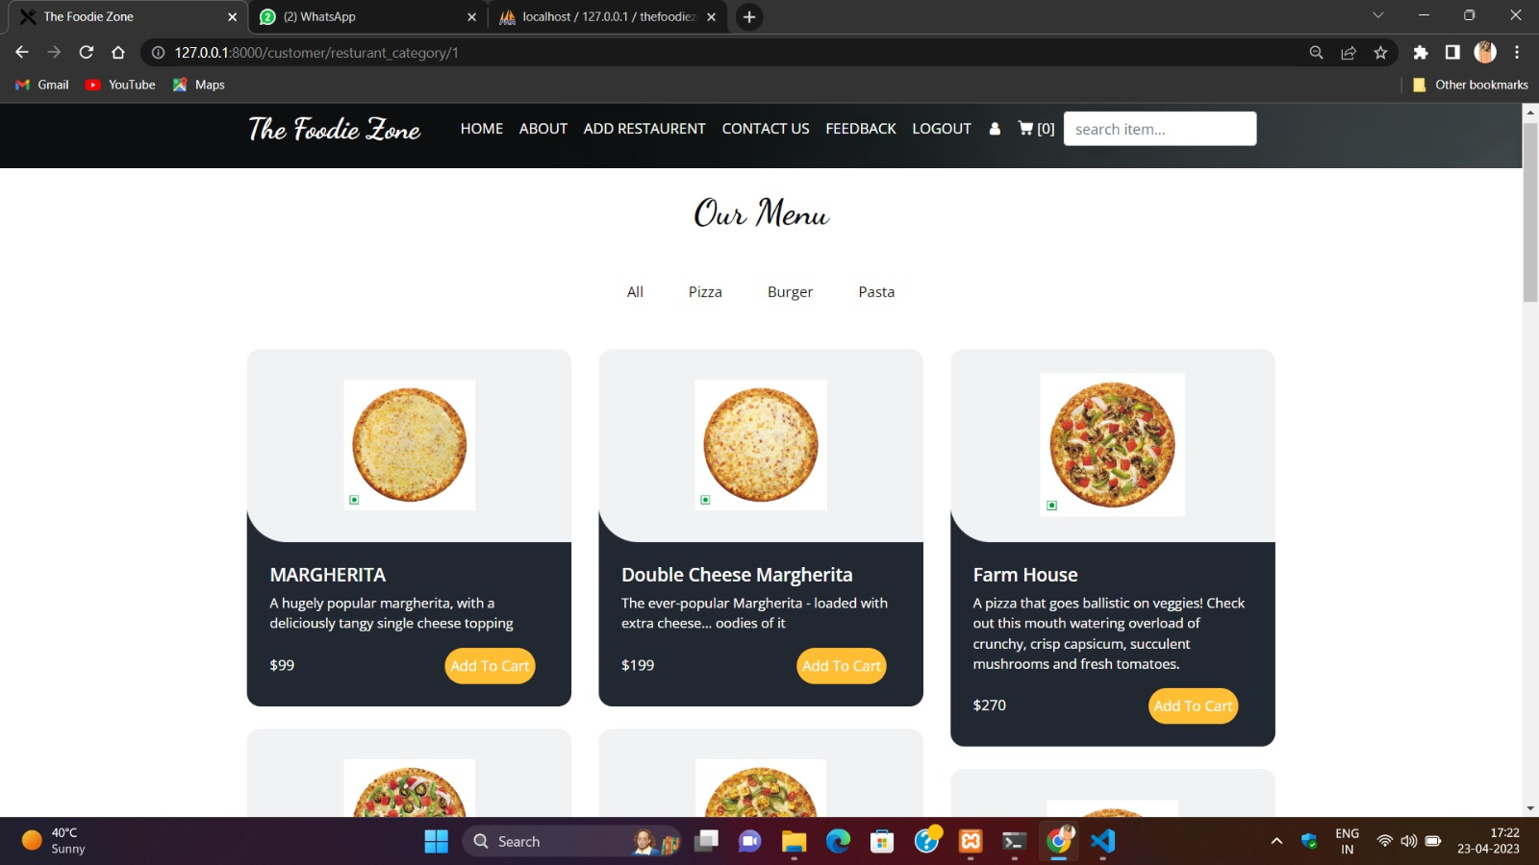

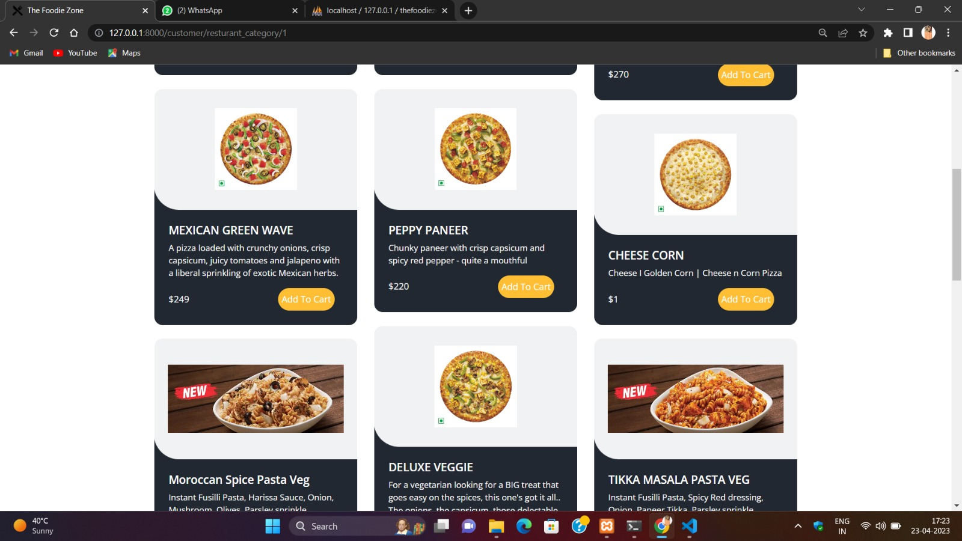

* **About Us Page:**

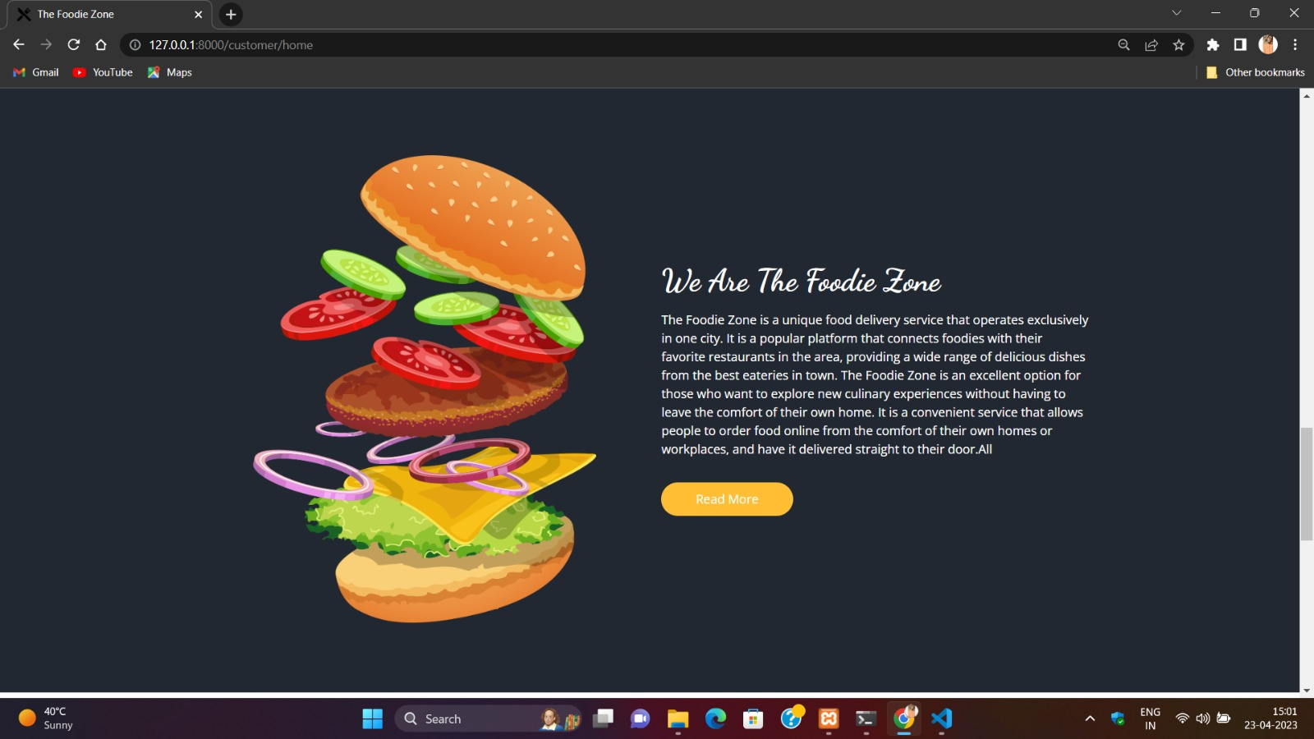

* **Feedback Page:**

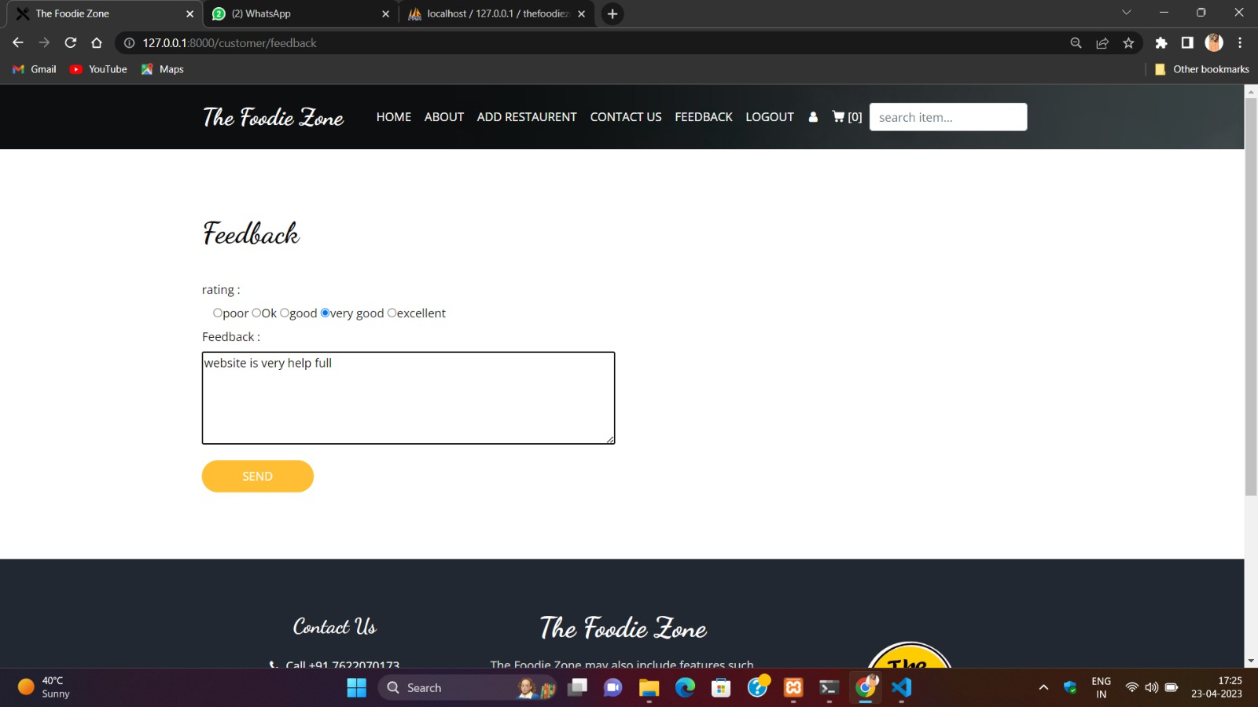

* **Inquiry Page:**

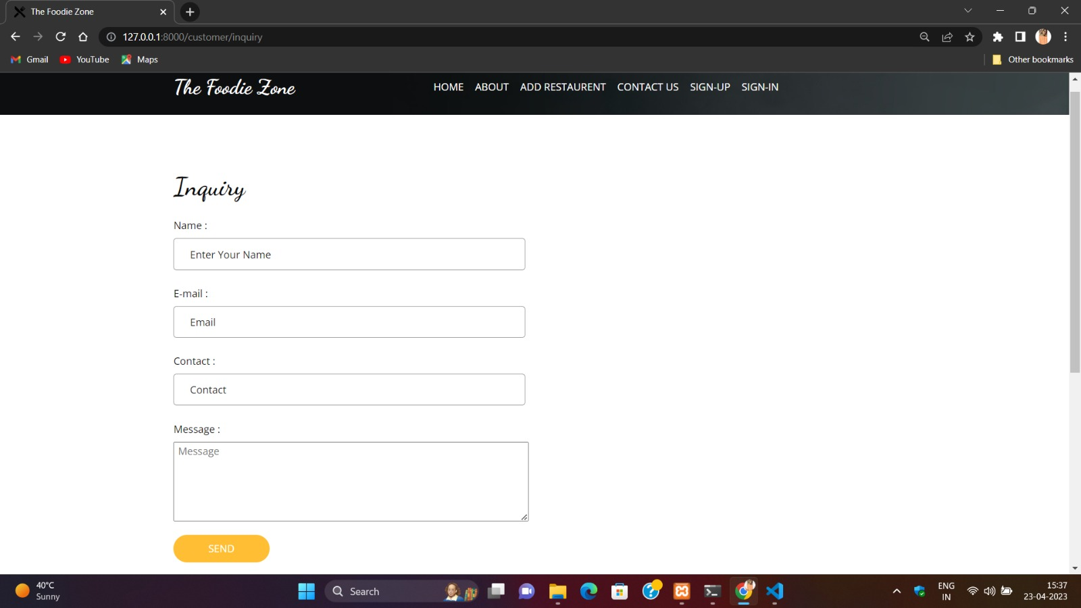

* **Cart Page:**

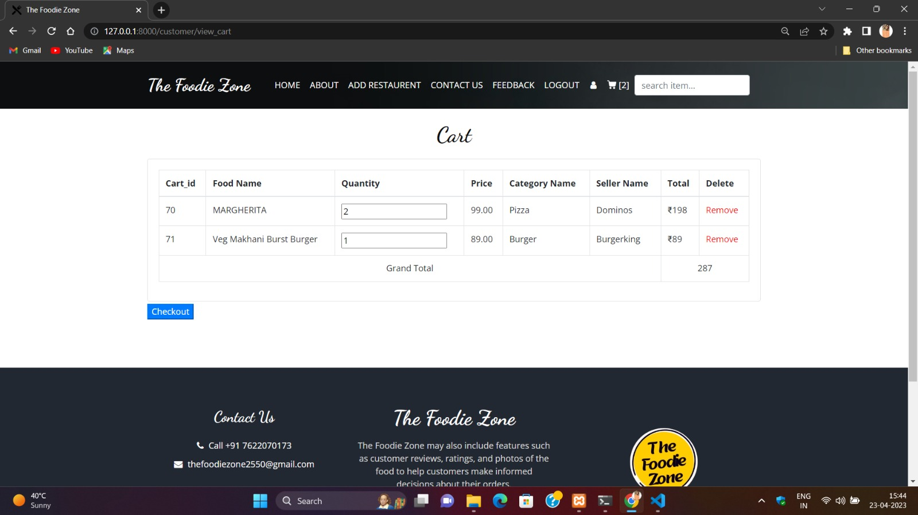

* **Admin Dashboard:**

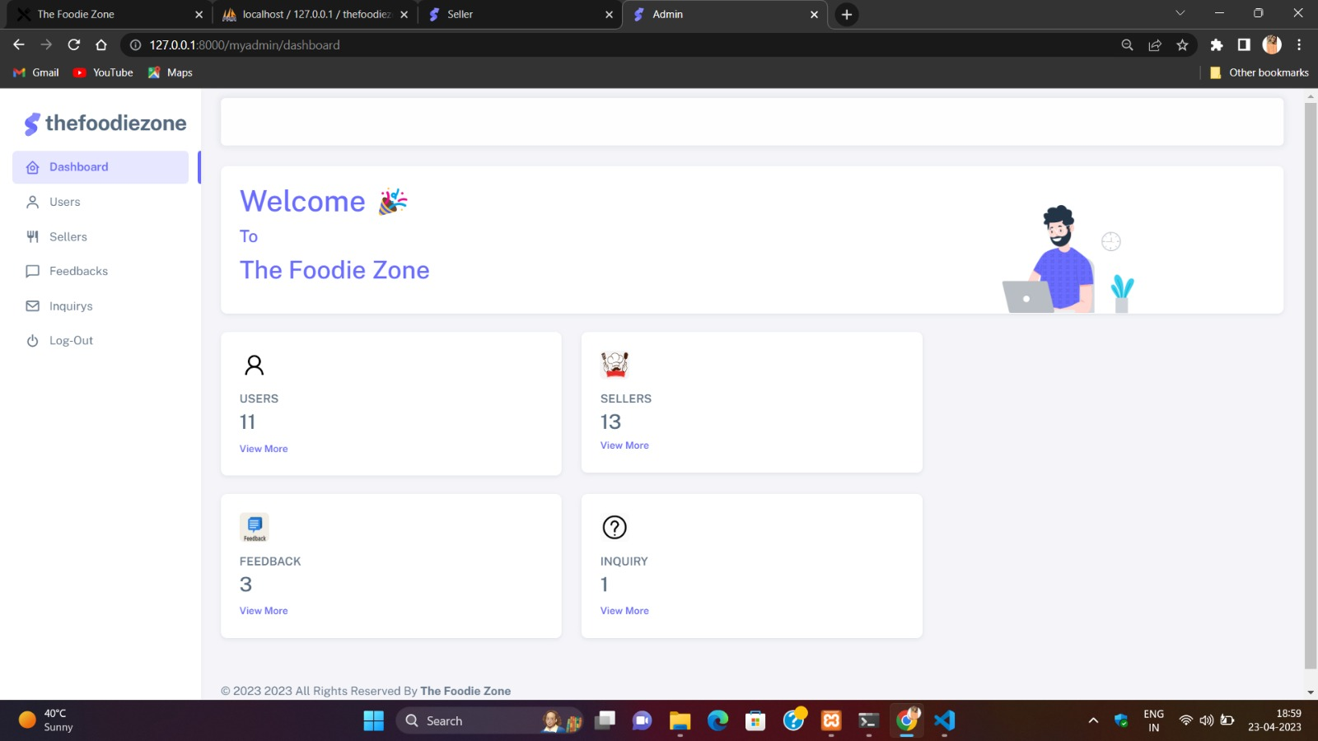

* **View User Page:**

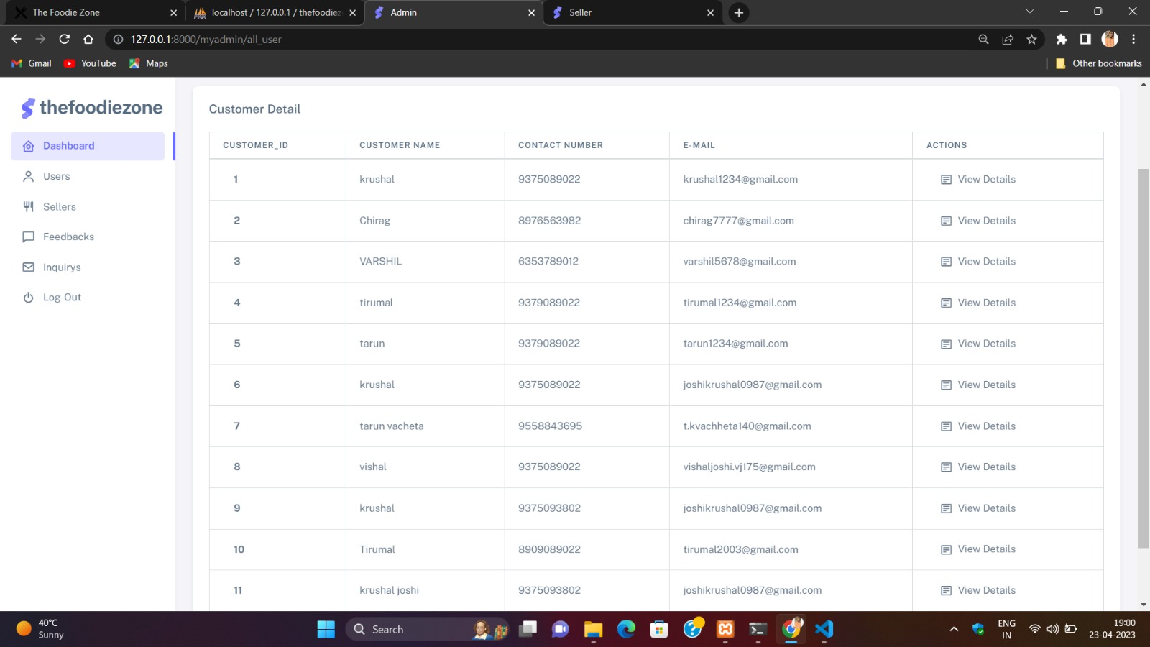

* **View User / View Details Page:**

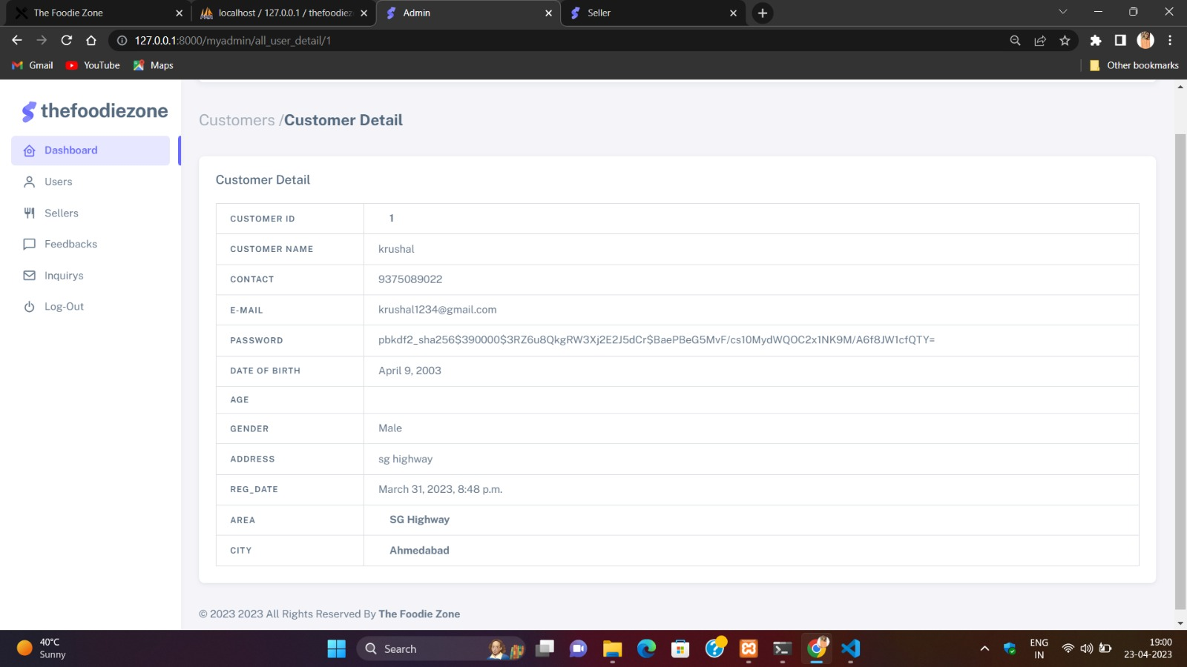

* **View Seller Page:**

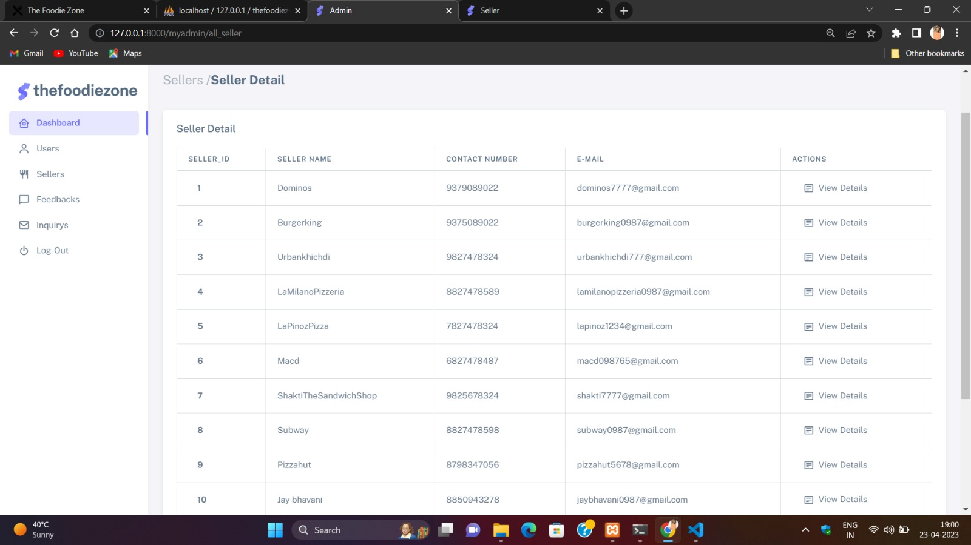

* **View Seller / View Details Page:**

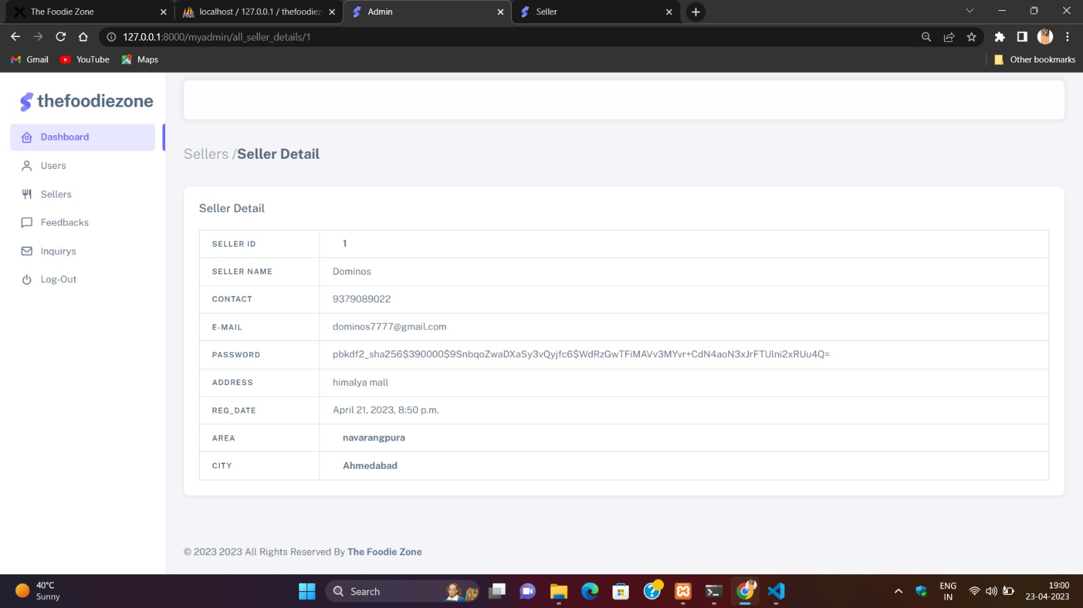

* **Feedback Page:**

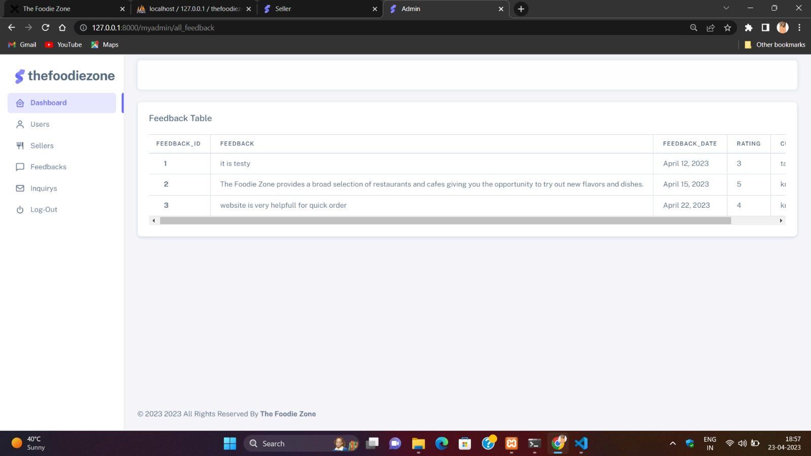

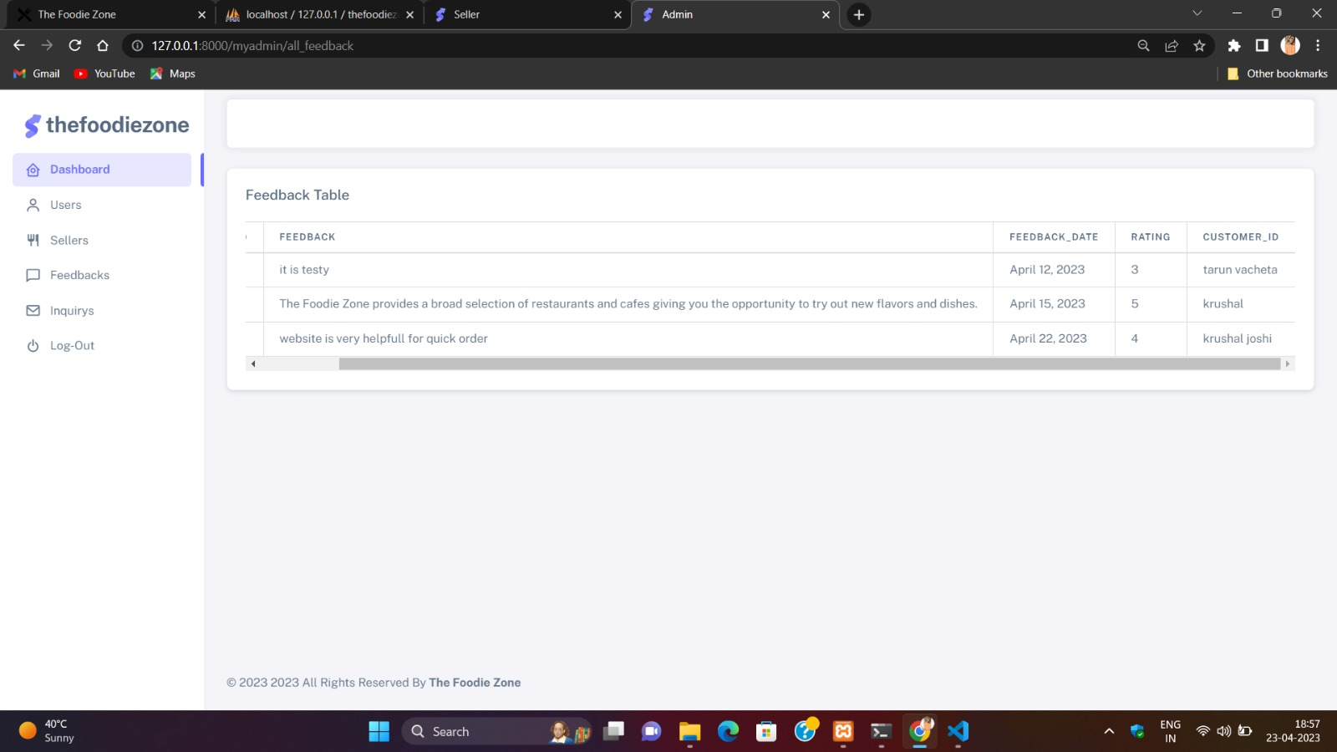

* **Inquiry Page:**

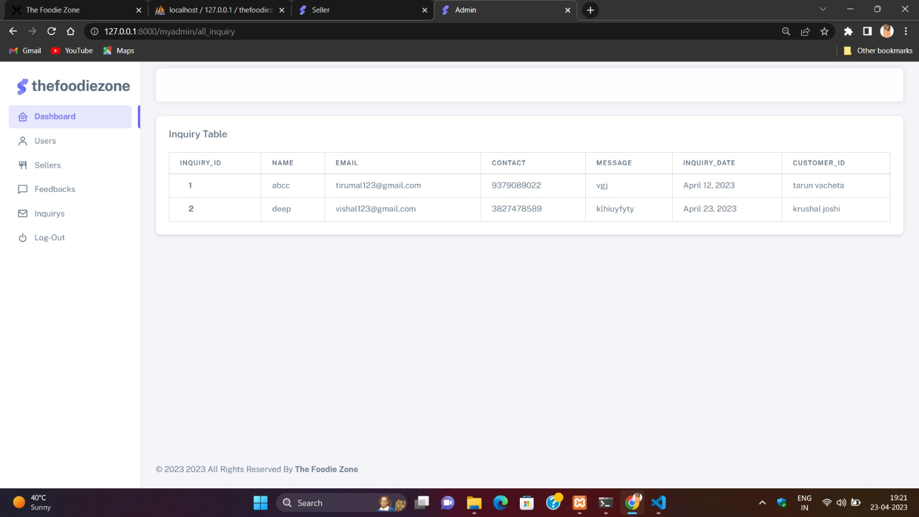

* **Seller Dashboard Page:**

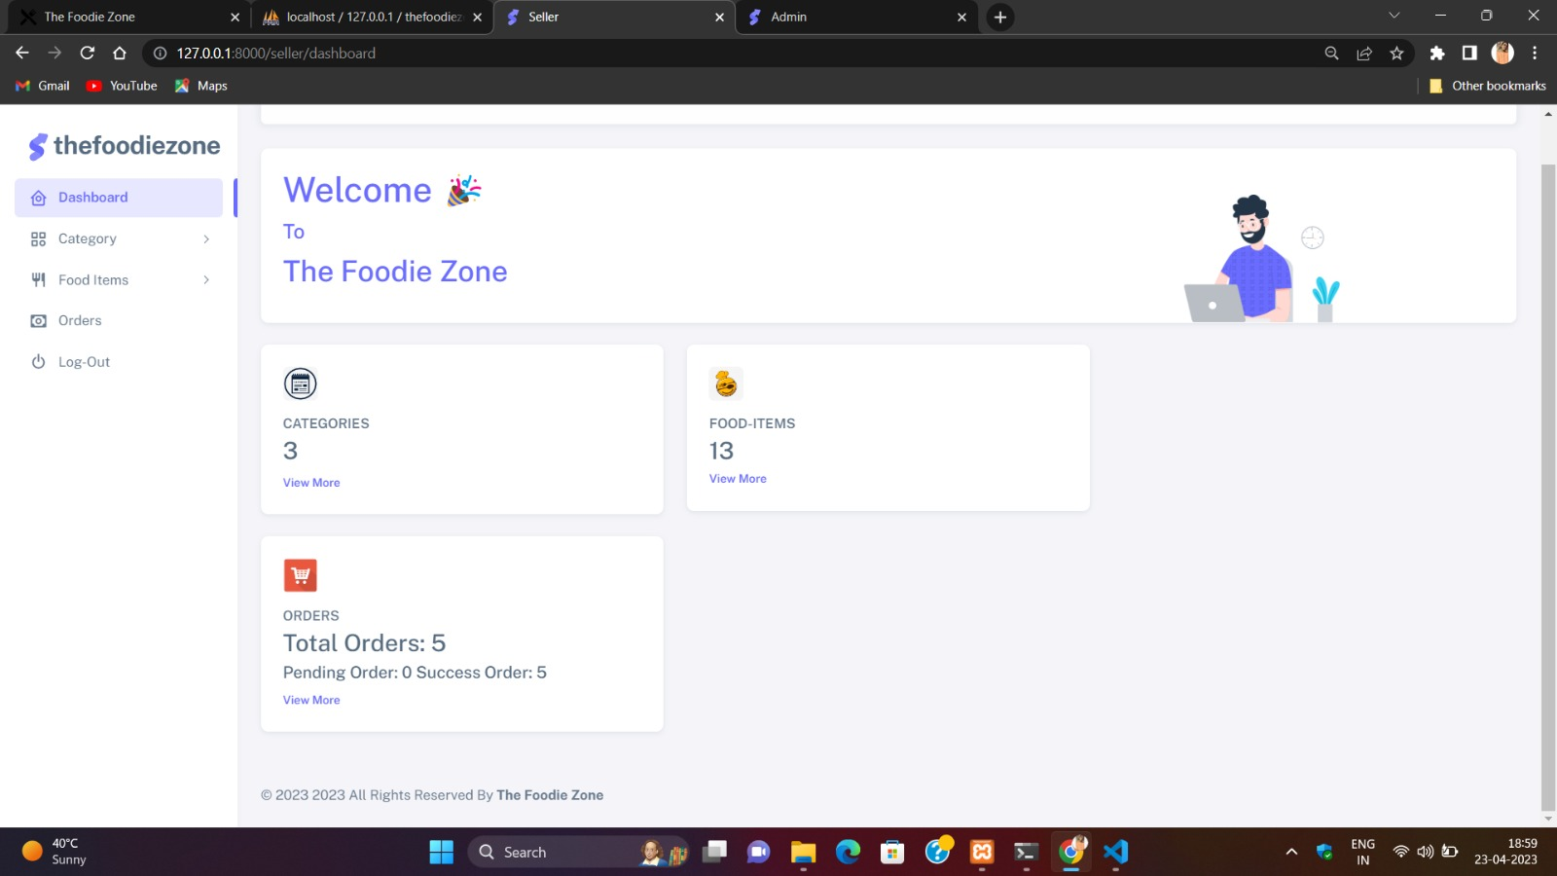

* **Category Page Input:**

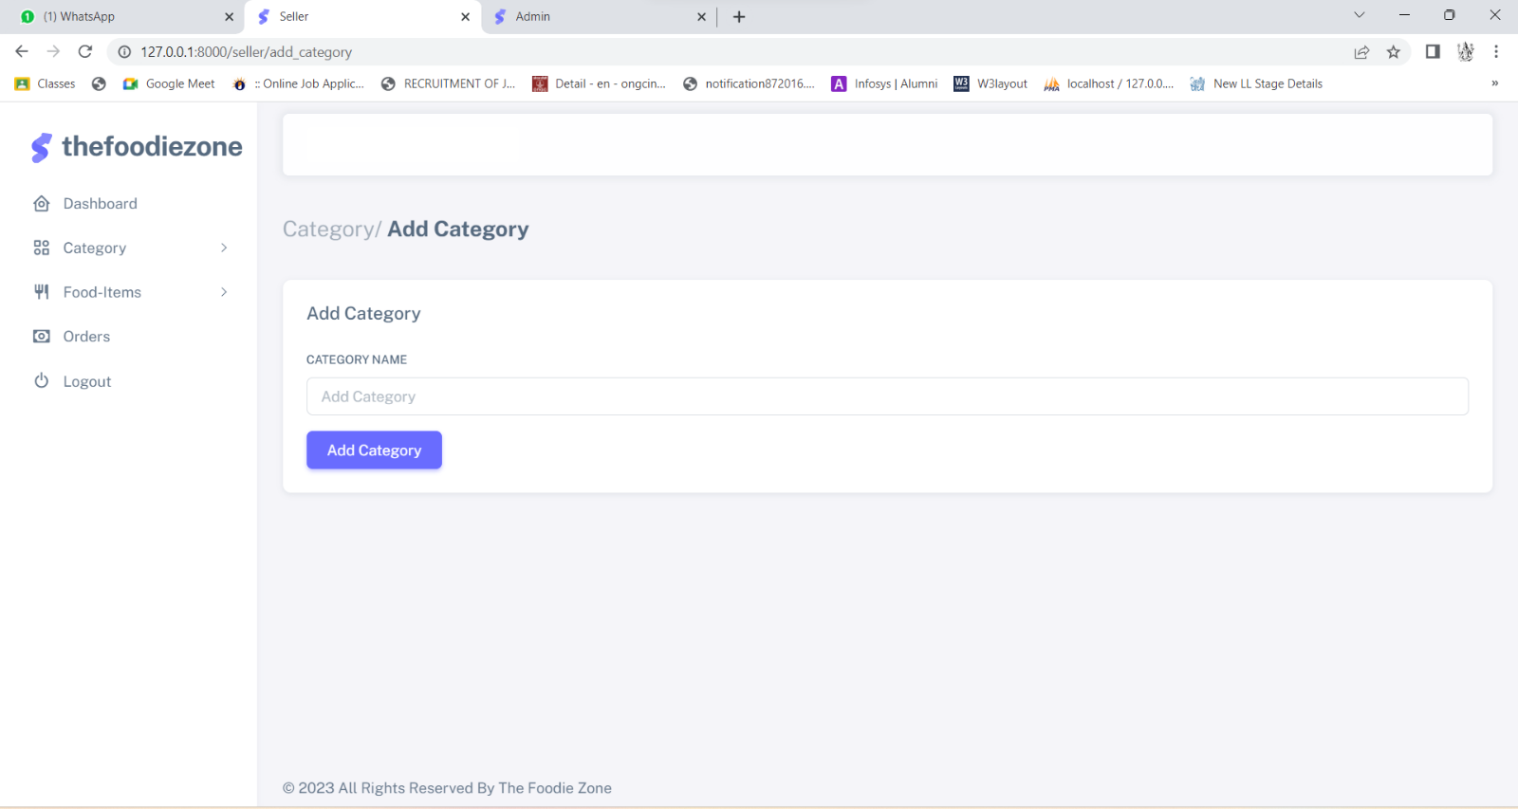

* **View Category Page:**

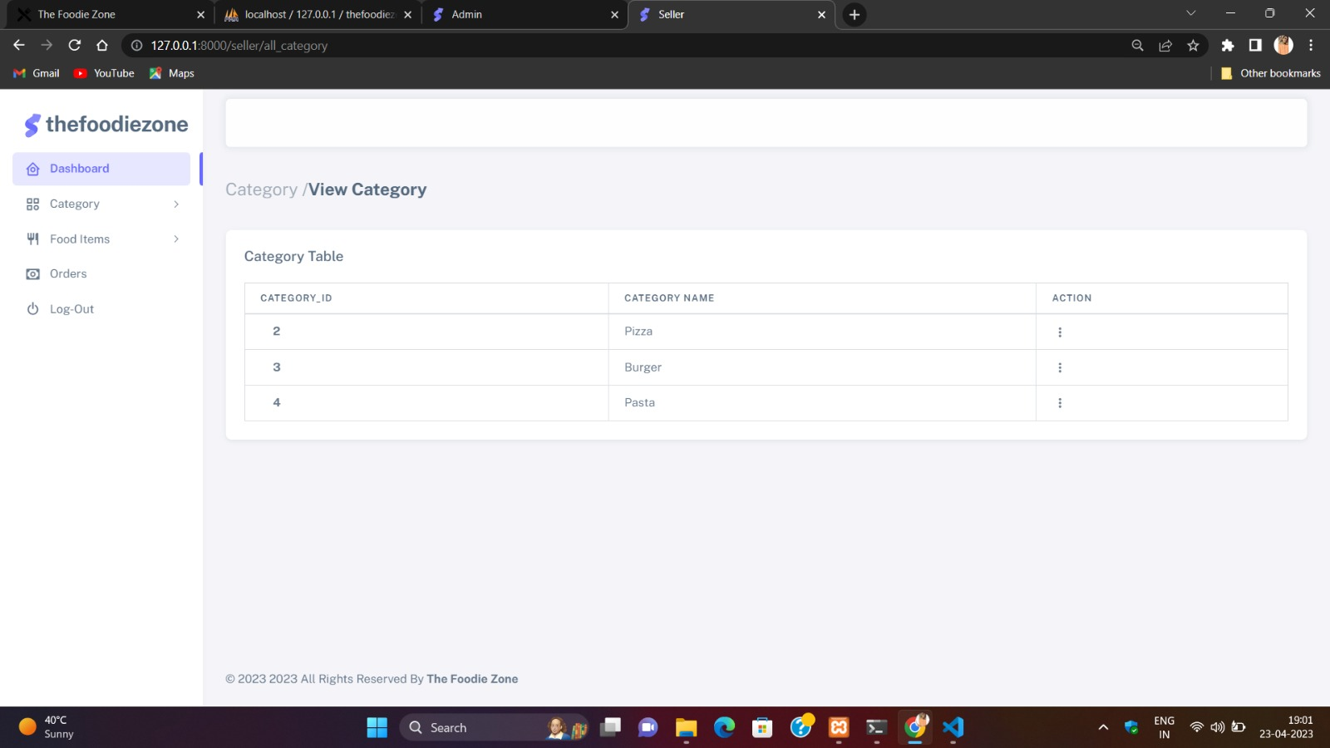

* **Food Item Page Input:**

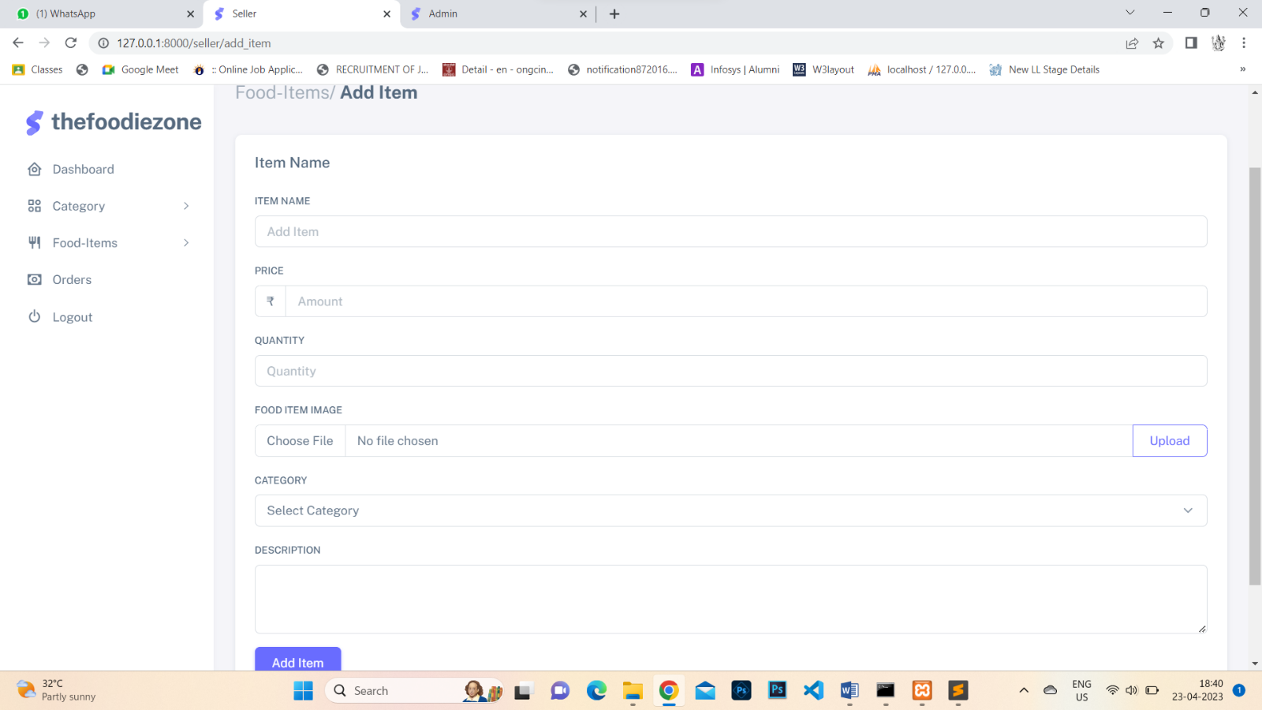

* **View Food Item Page:**

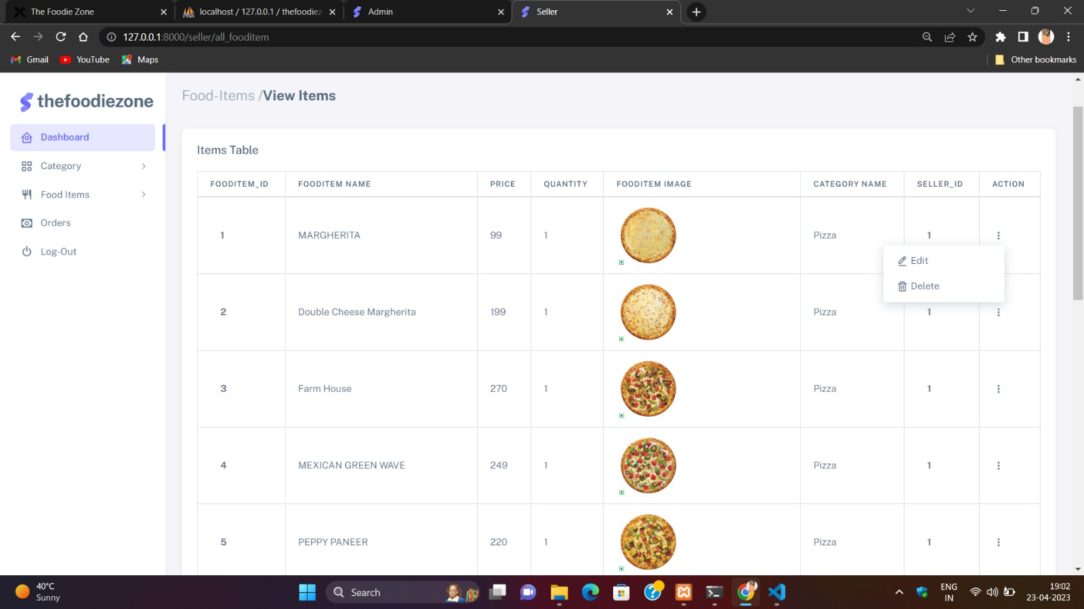

* **View Order Page:**

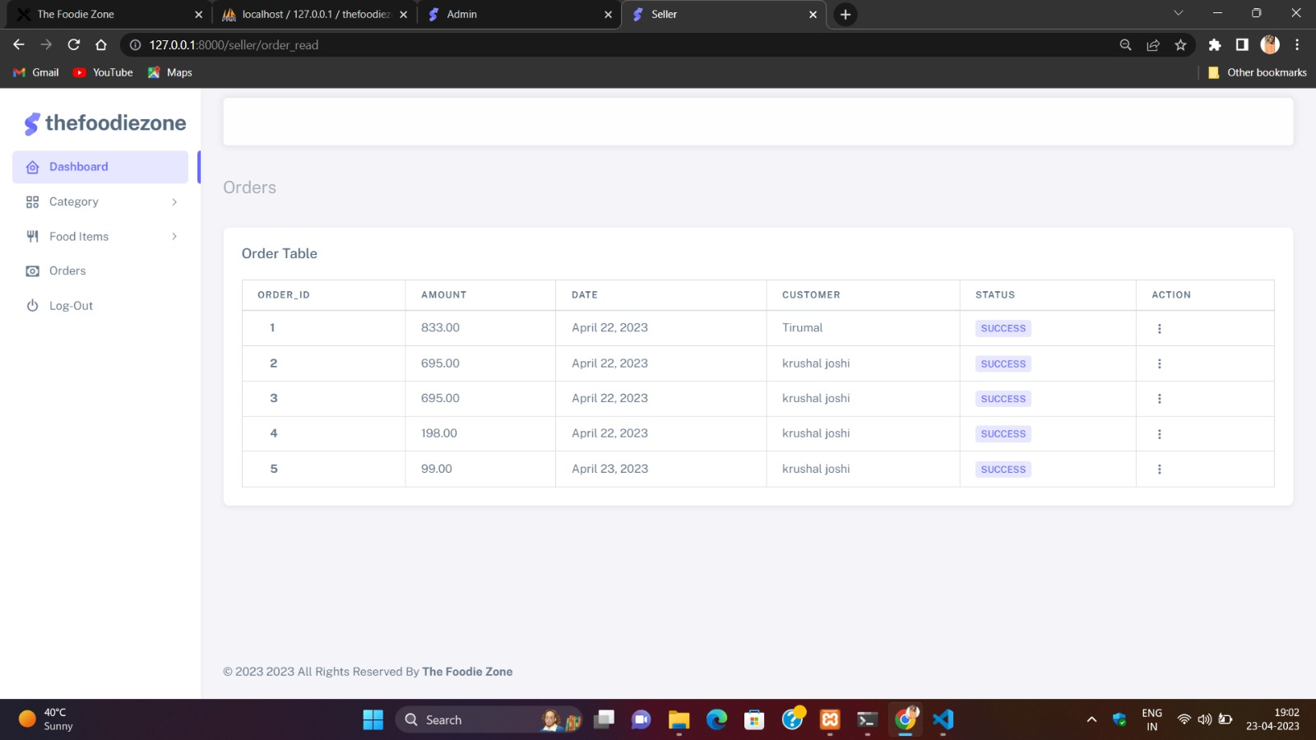

* **View Order/ View Order Details:**

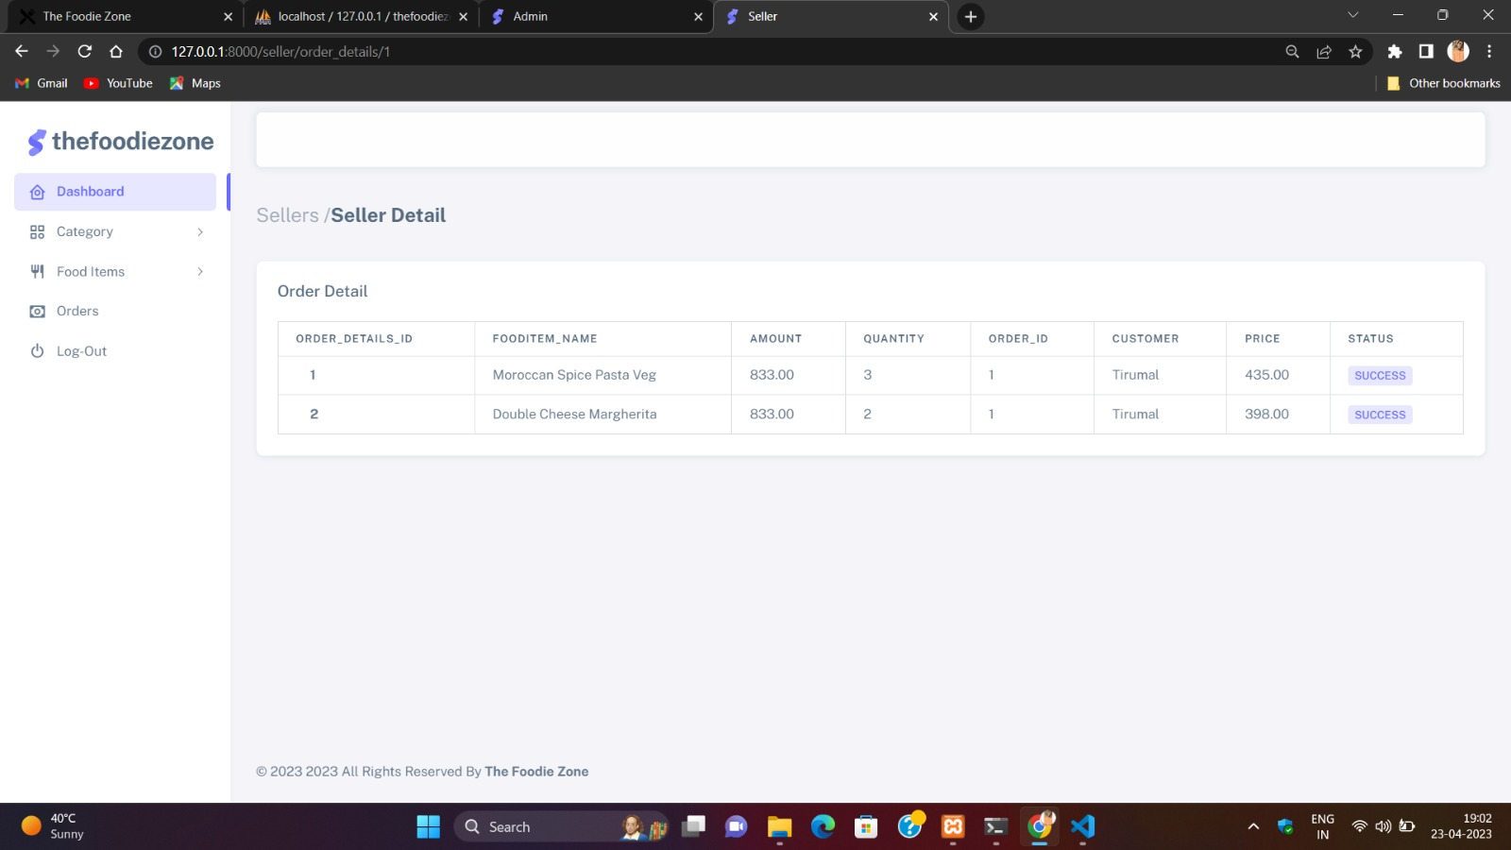

## **4.5 SYSTEM NAVIGATION**

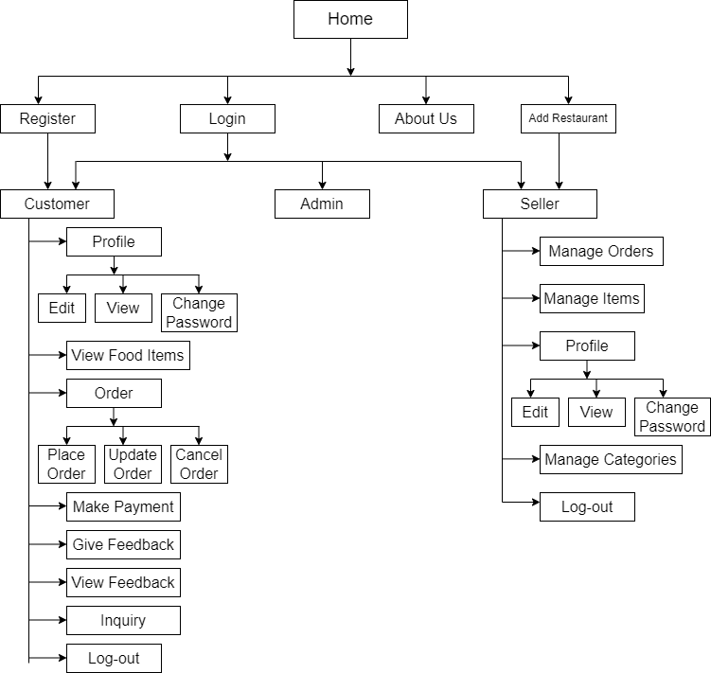

# **CHAPTER-5: INPUT AND OUTPUT DESIGN**

* **Sign In / Log In Input:**

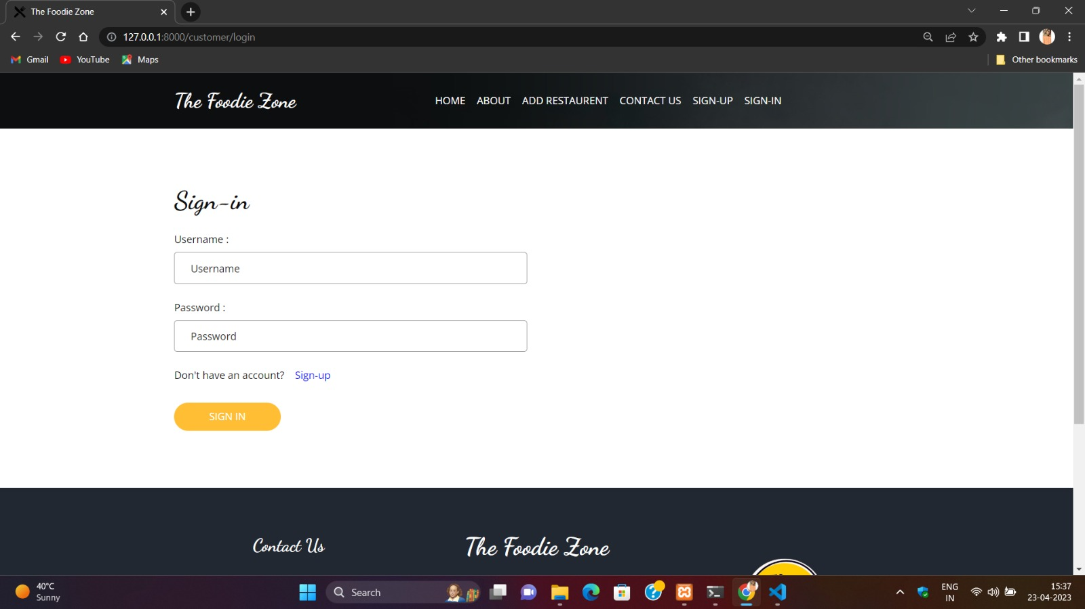

* **Sign In / Log In Output:**



* **Admin Sign In / Log In Input:**

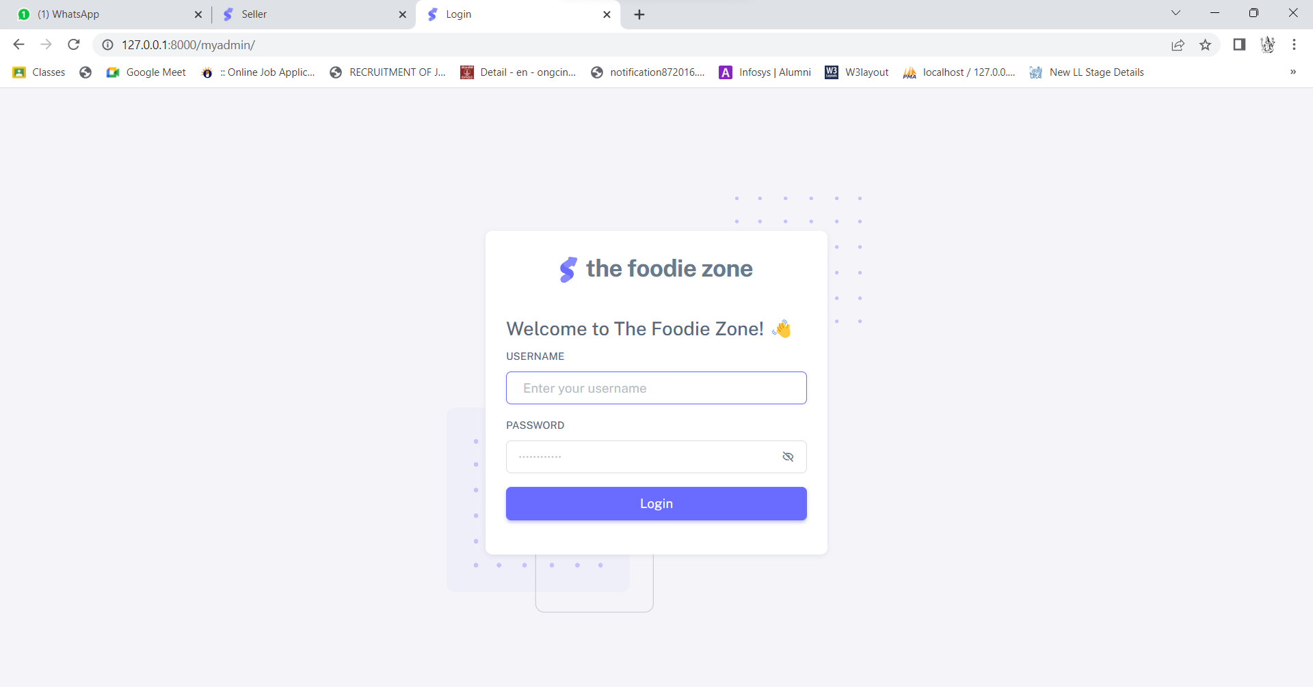

* **Admin Sign In / Log In Output [Dashboard]:**



* **Seller Sign In / Log In Input:**

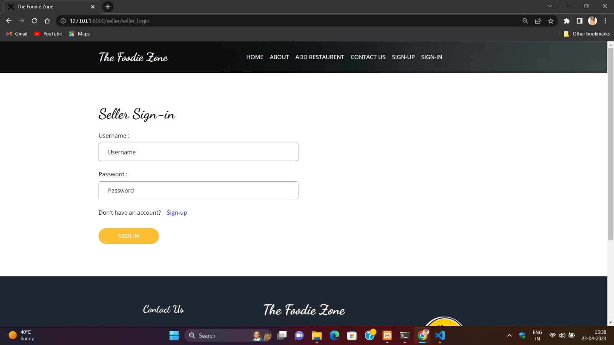

* **Seller Sign In / Log In Output [Dashboard]:**



* **Inquiry Page Input:**



* **Inquiry Page Output:**



* **Feedback Page Input:**

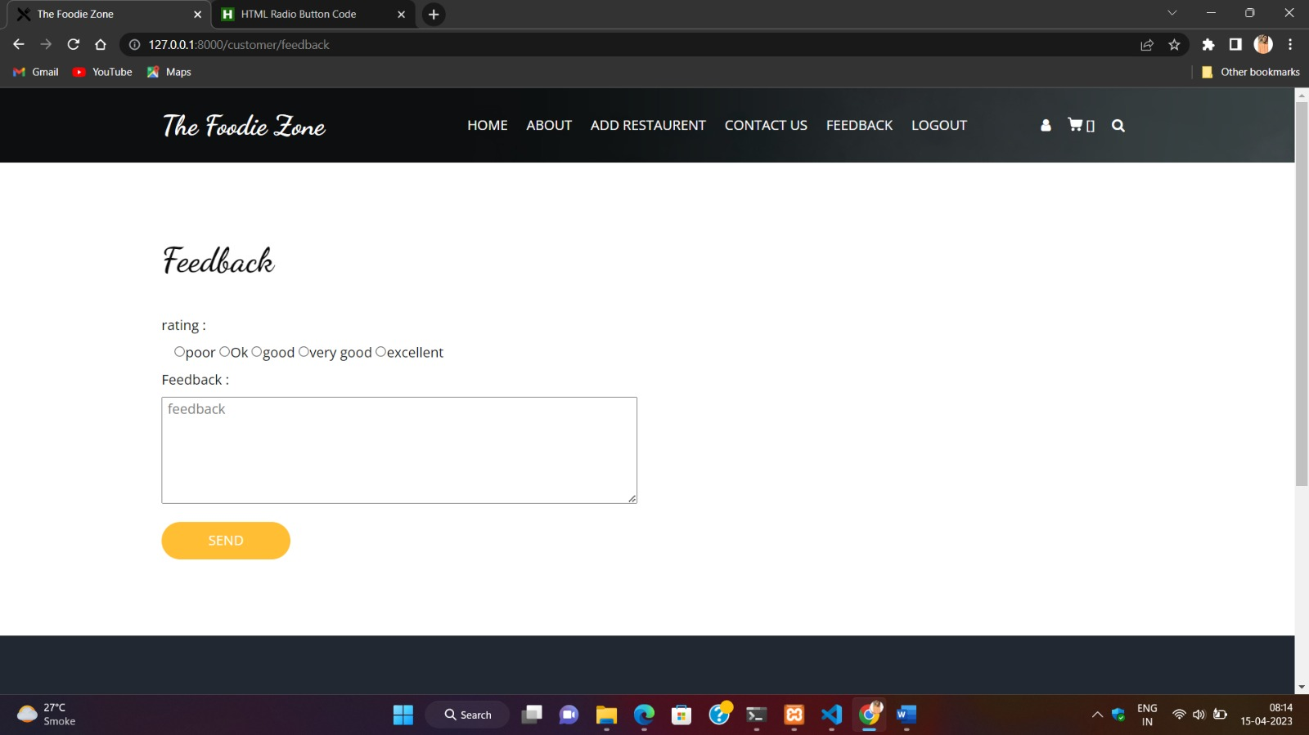

* **Feedback Page Output:**





* **Check Out Page Input:**

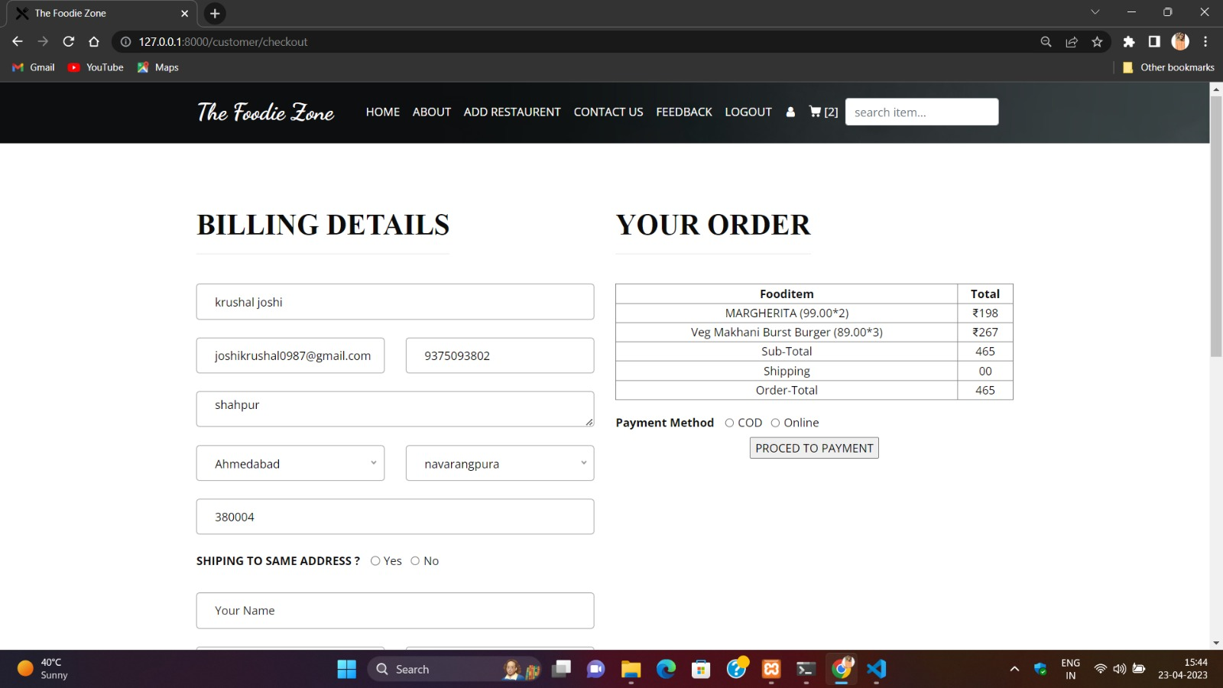

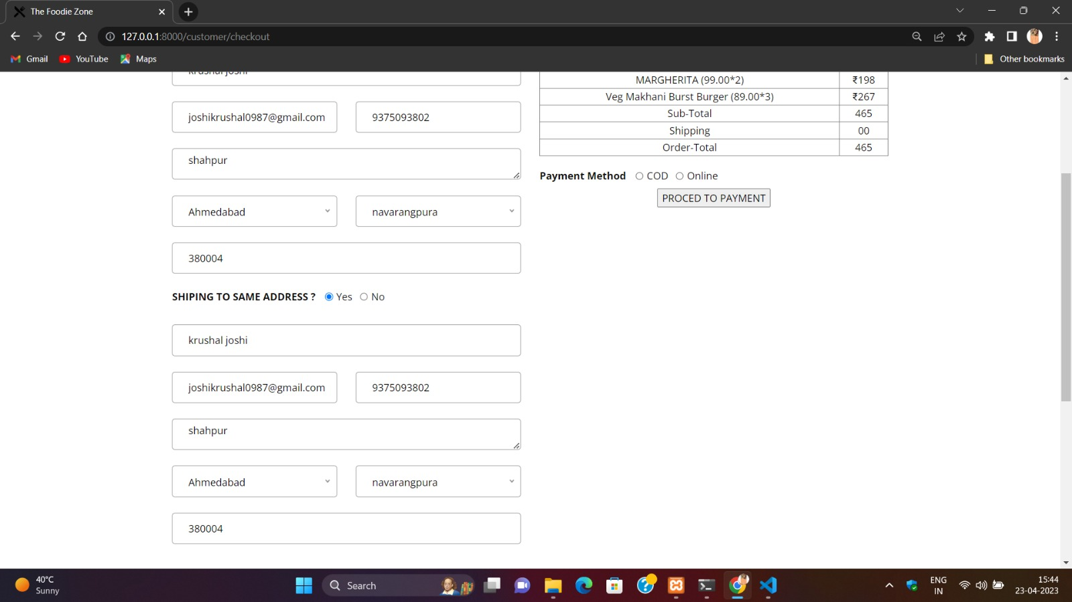

* **Proceed to Payment Output:**

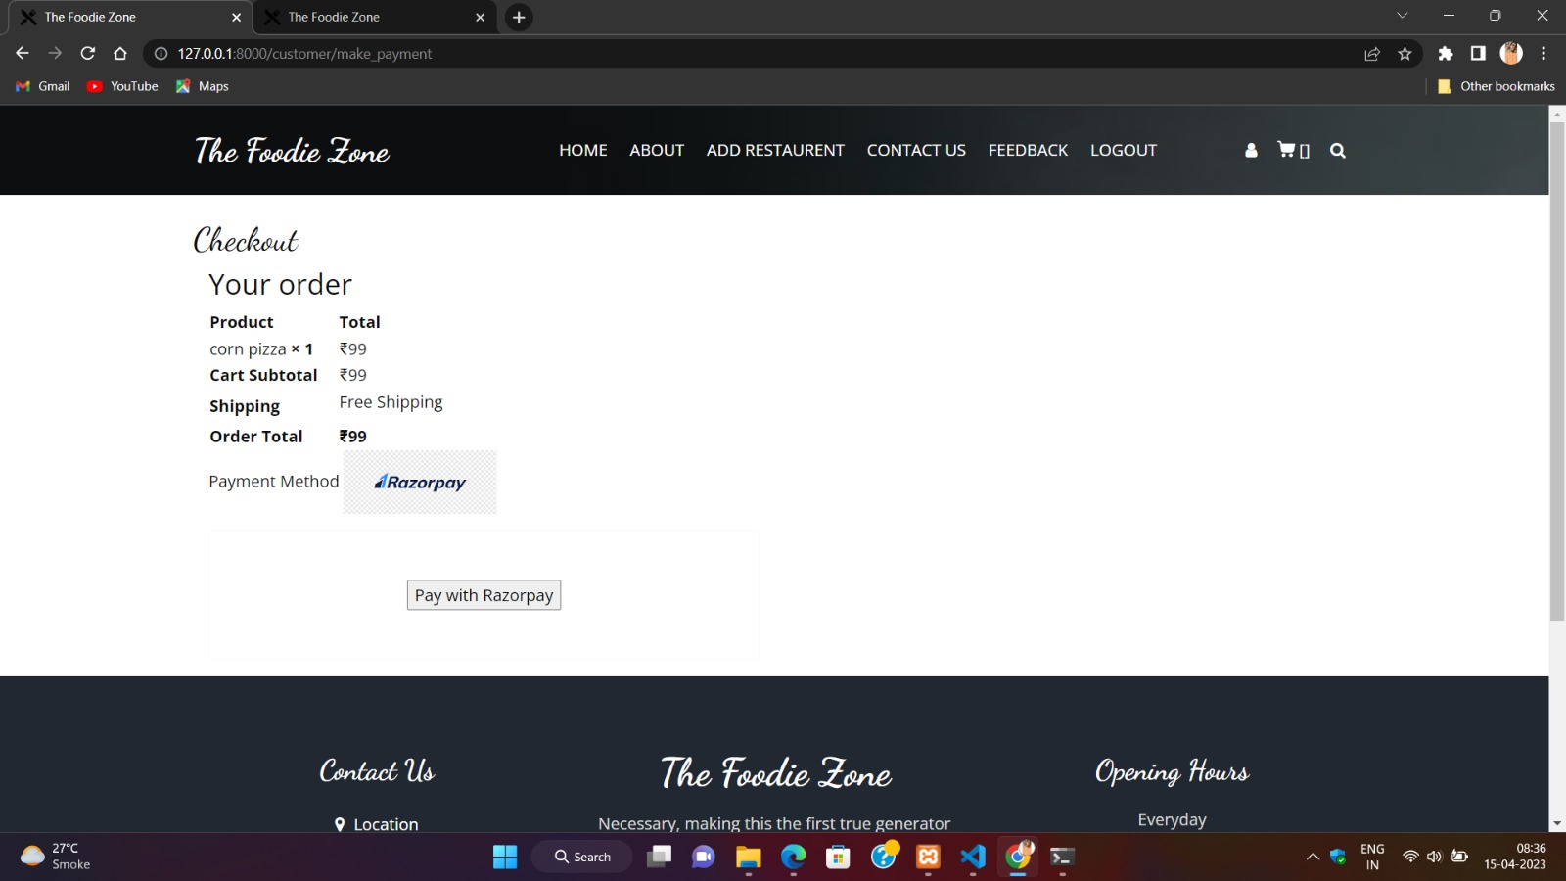

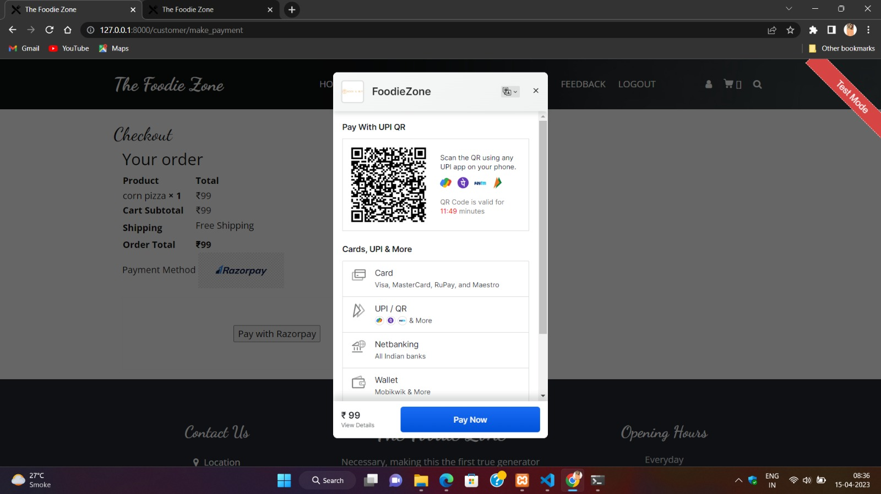

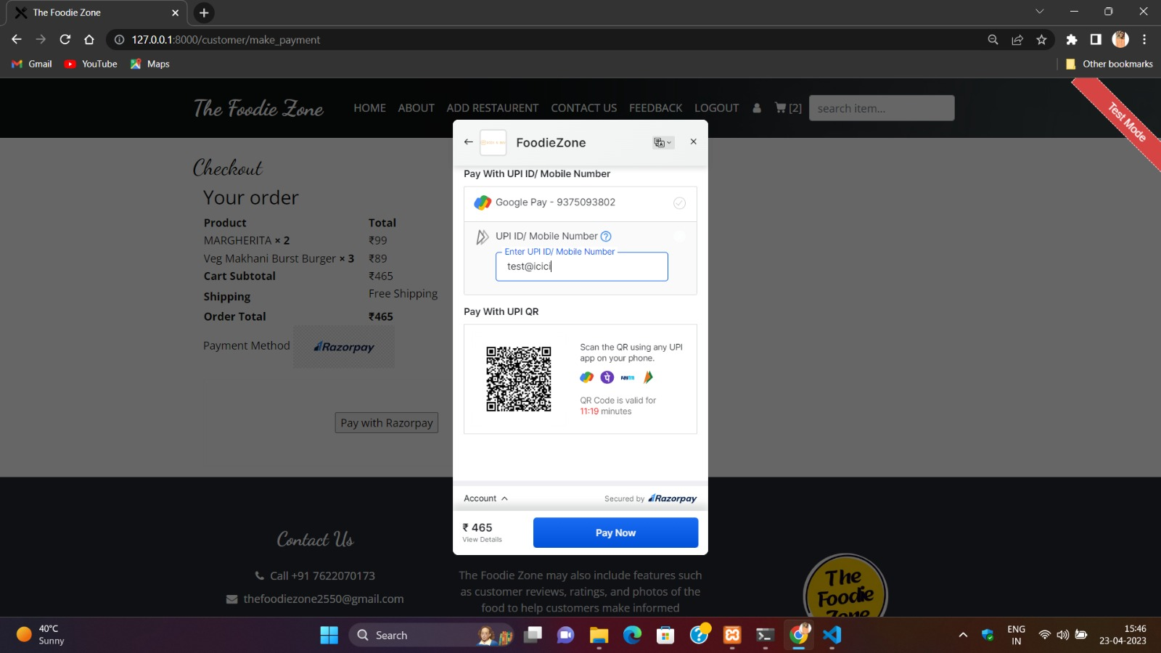

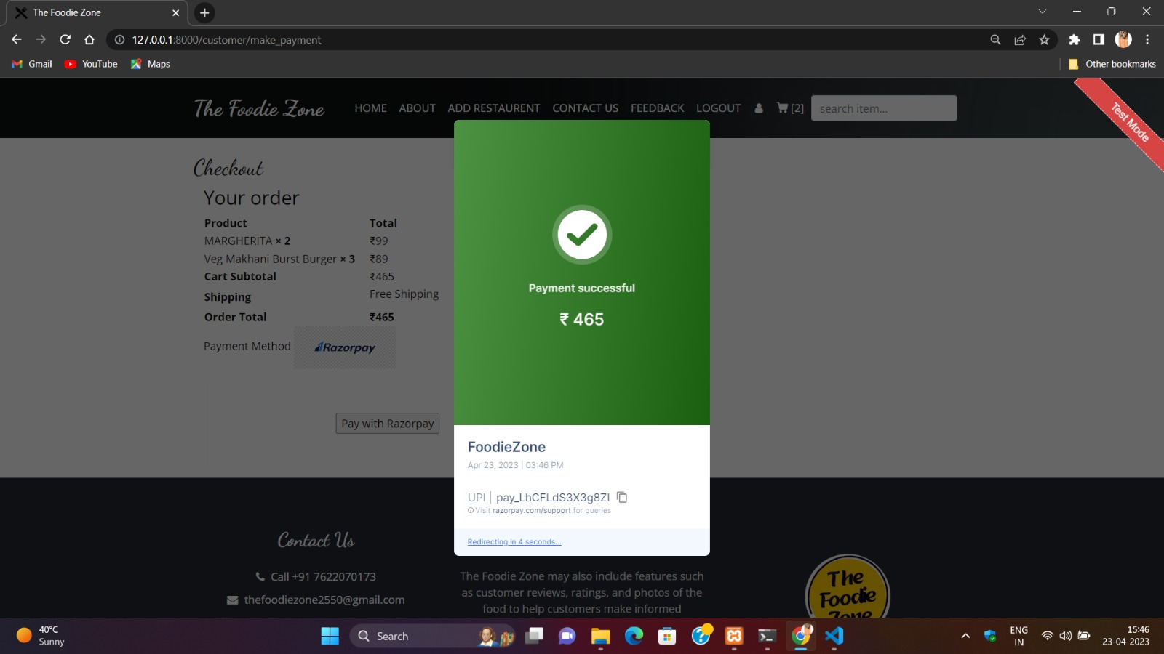

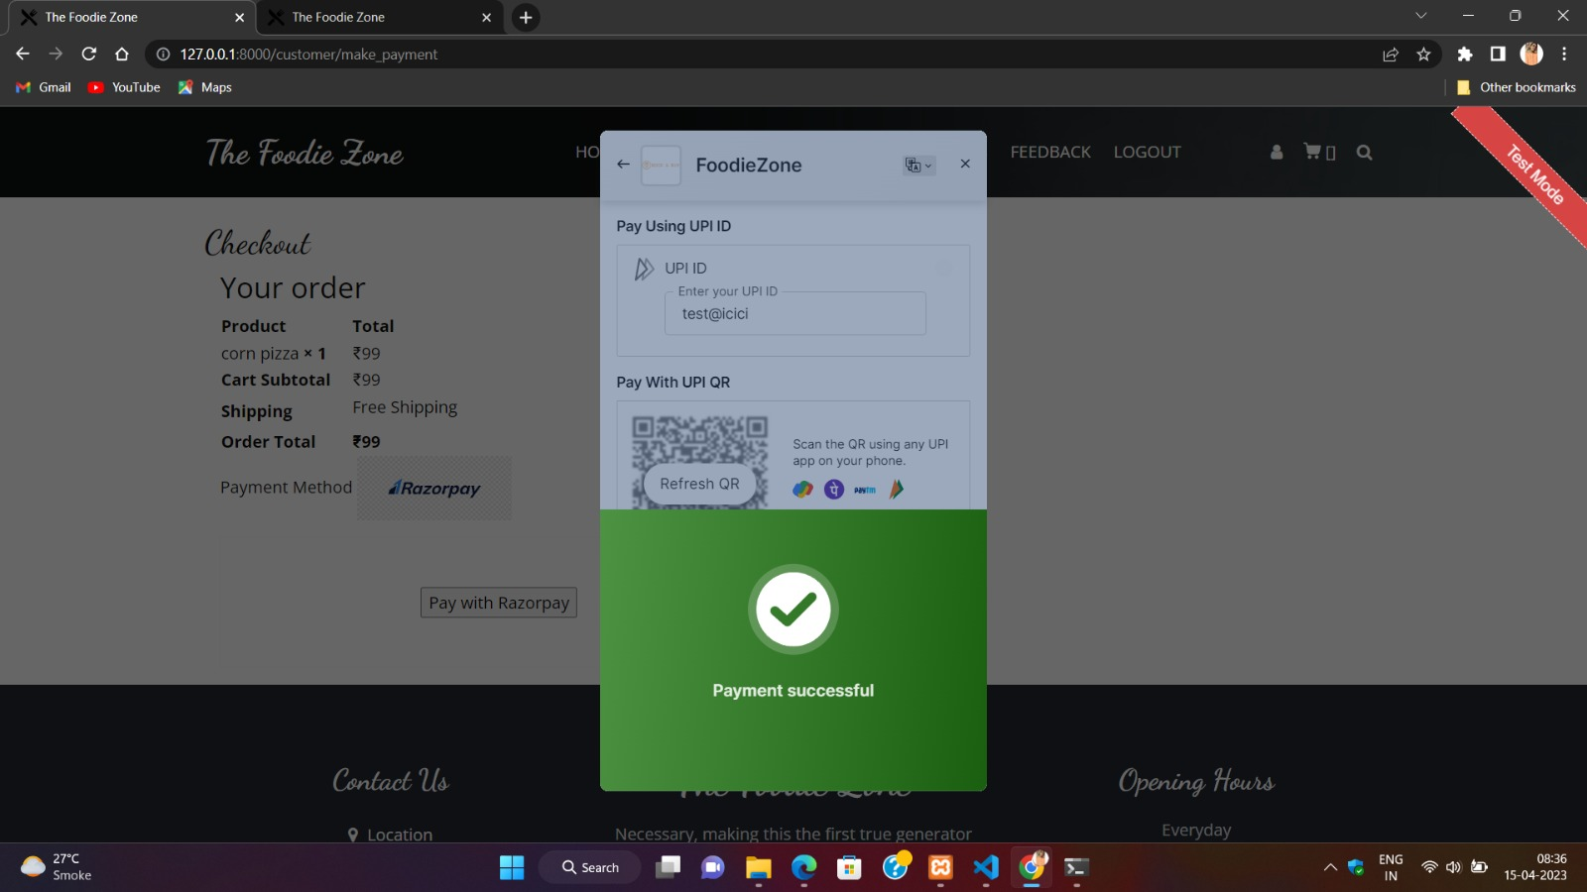

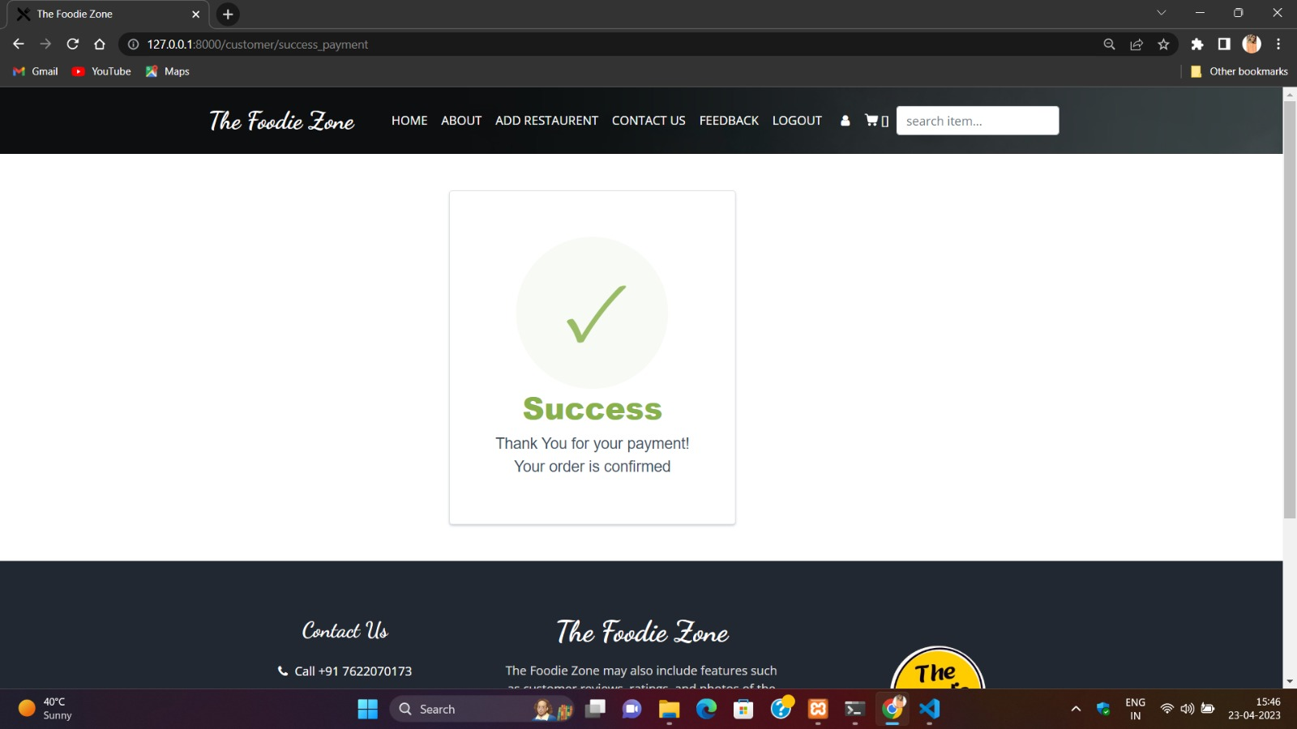

* **Bill generation:**

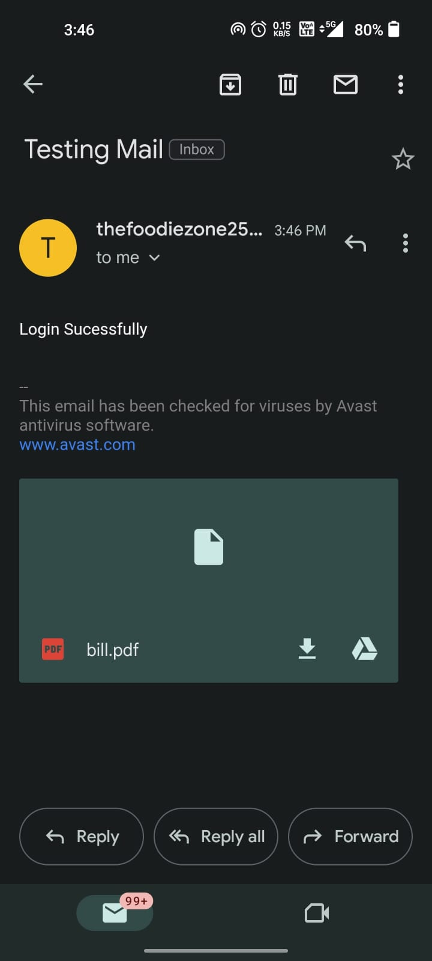 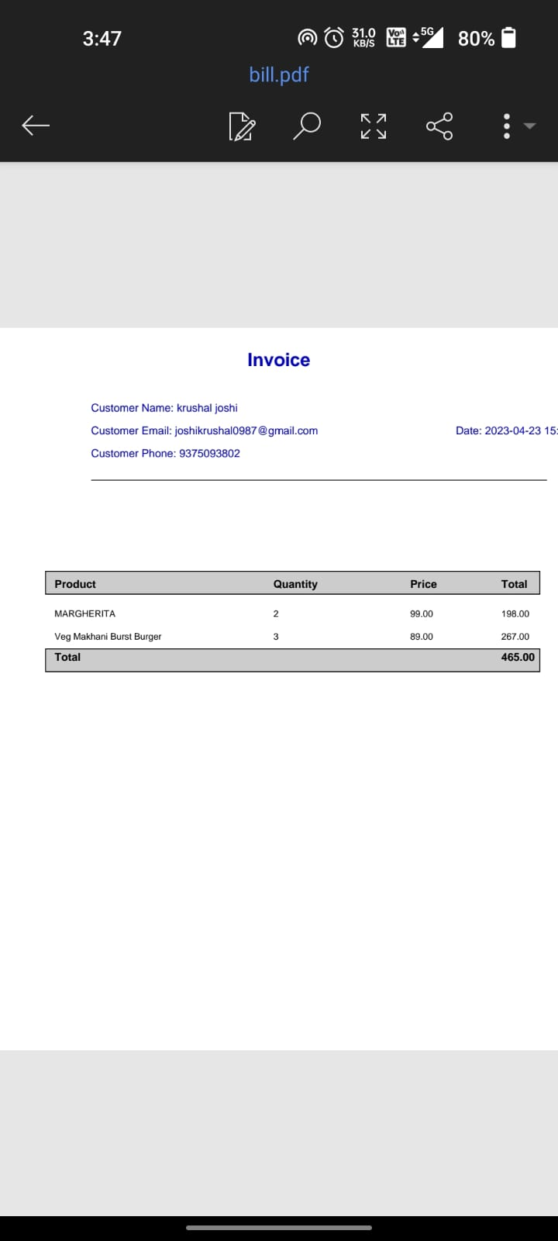

* **Category Page Input:**



* **Category Page Output:**



* **Food Item Page Input:**



* **Food Item Page Output:**



# **CHAPTER-6: TESTING**

* **None Of Fields Can Be Empty:**

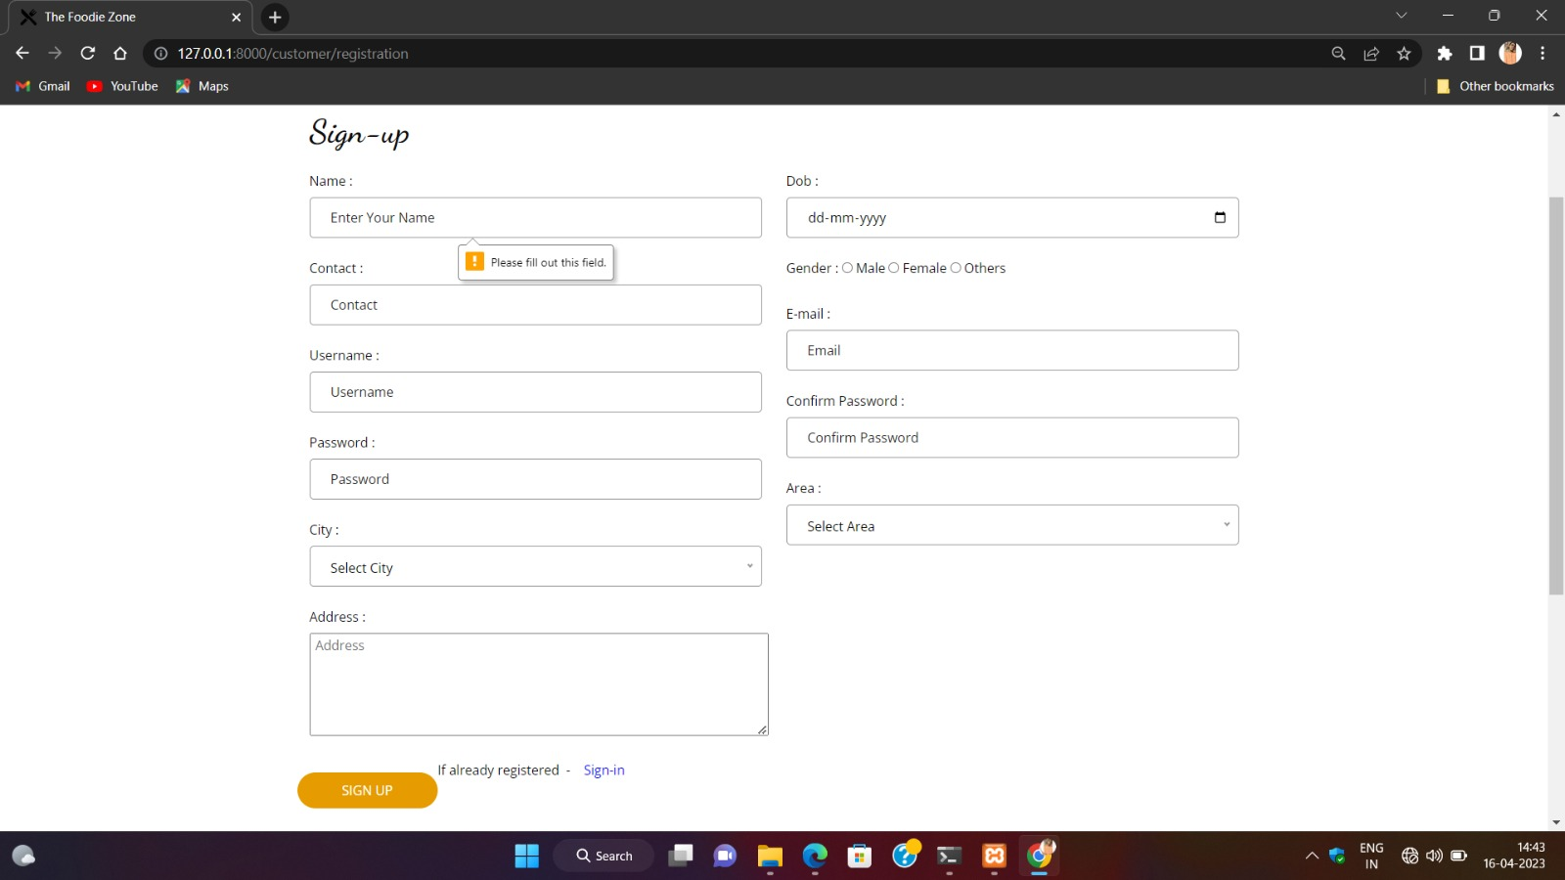

* **Contact Us Page Validation:**
* **Email Validation:**

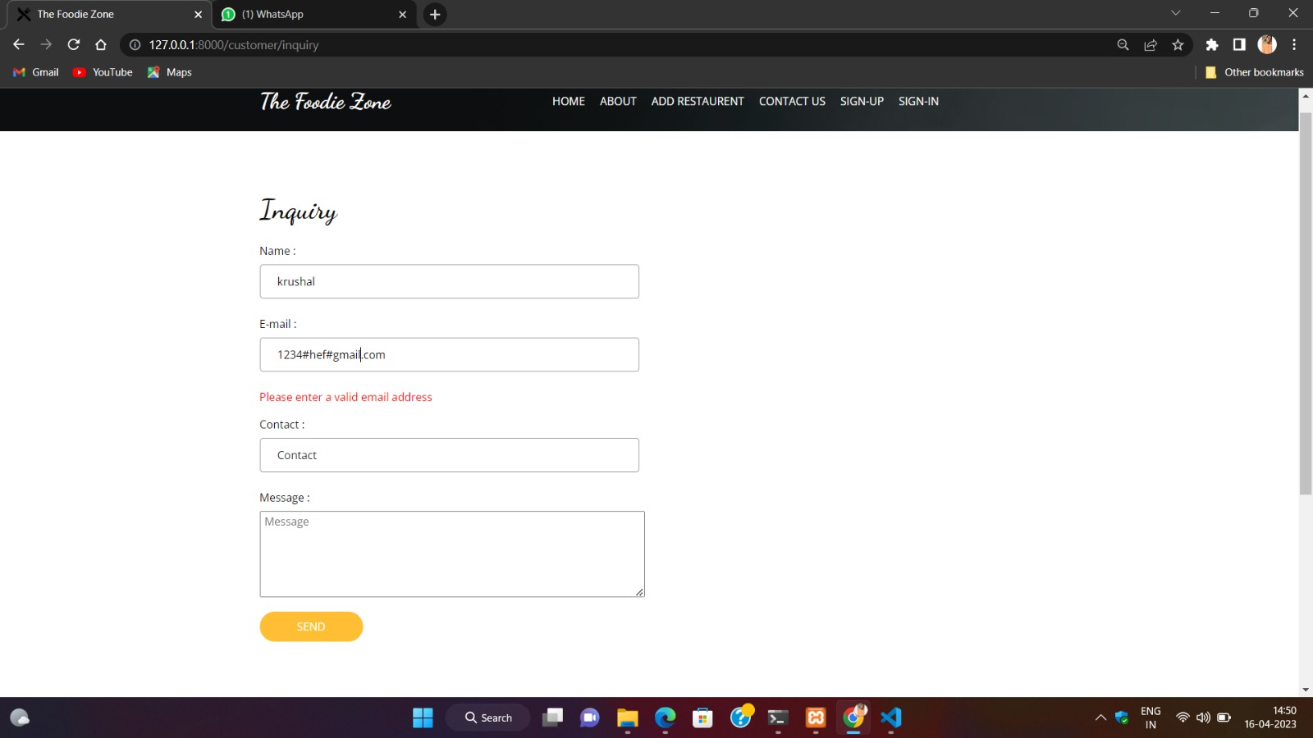

* **Sign Up Page Validation:**
* **Phone Number Validation:**

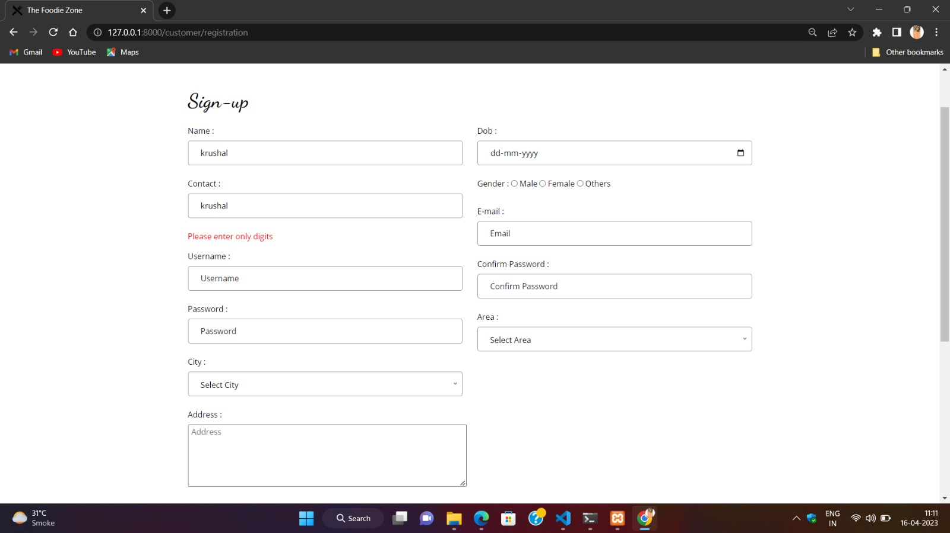

* **Name Validation:**

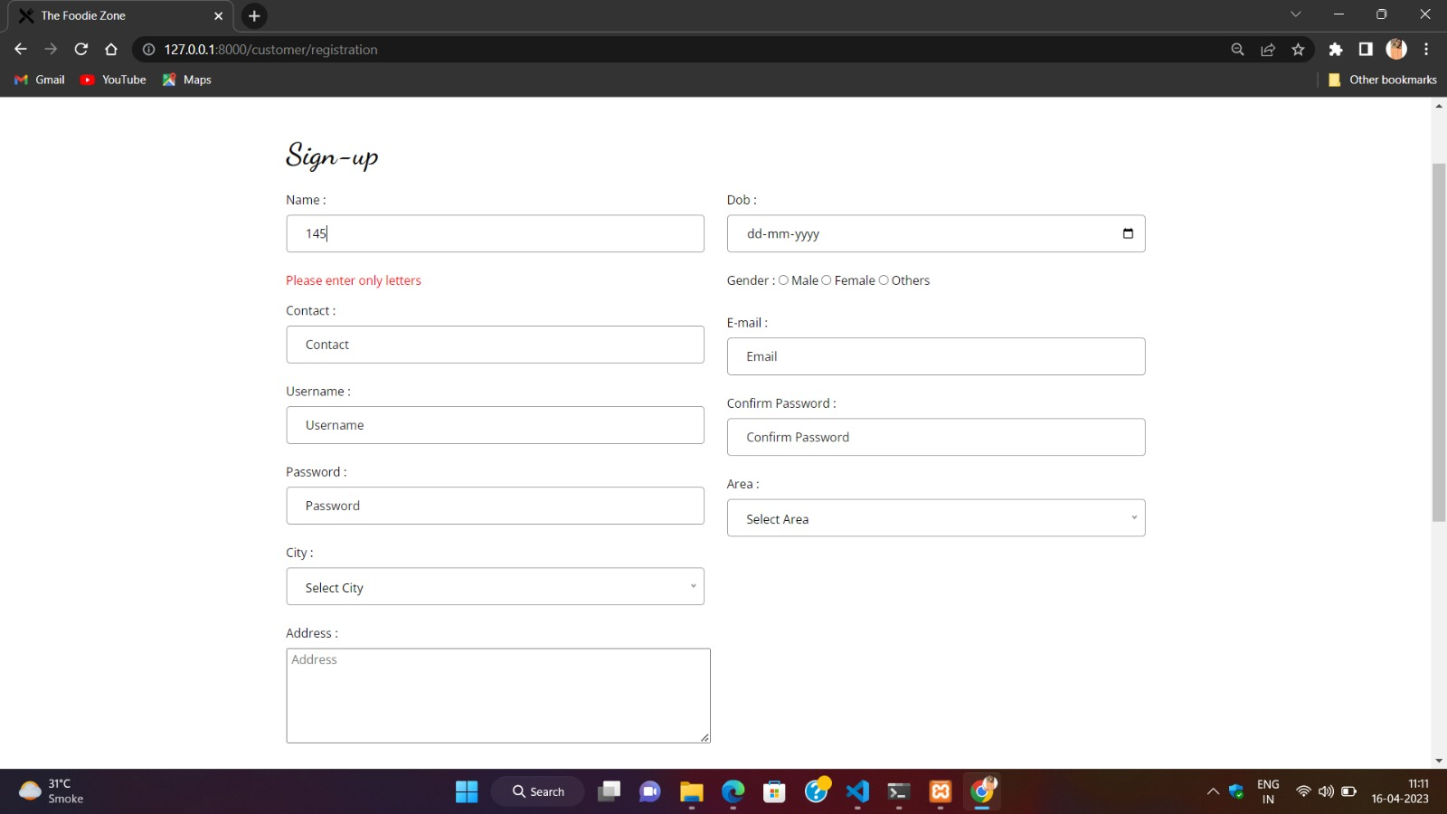

* **Email Validation:**

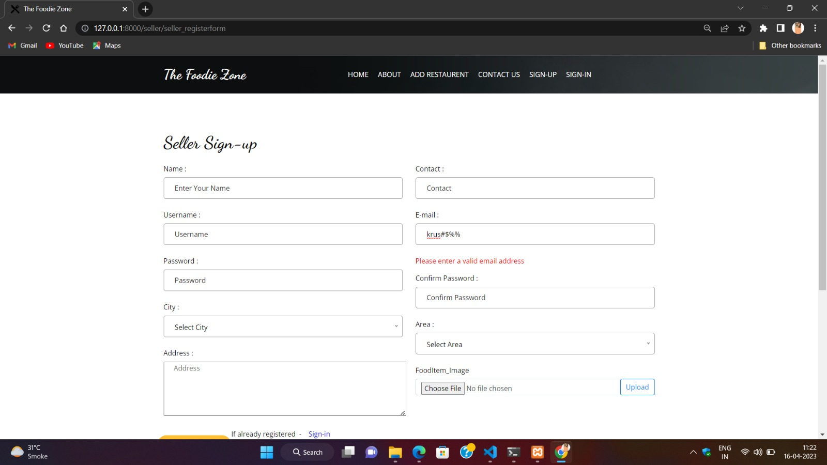

* **Password Field Validation:**

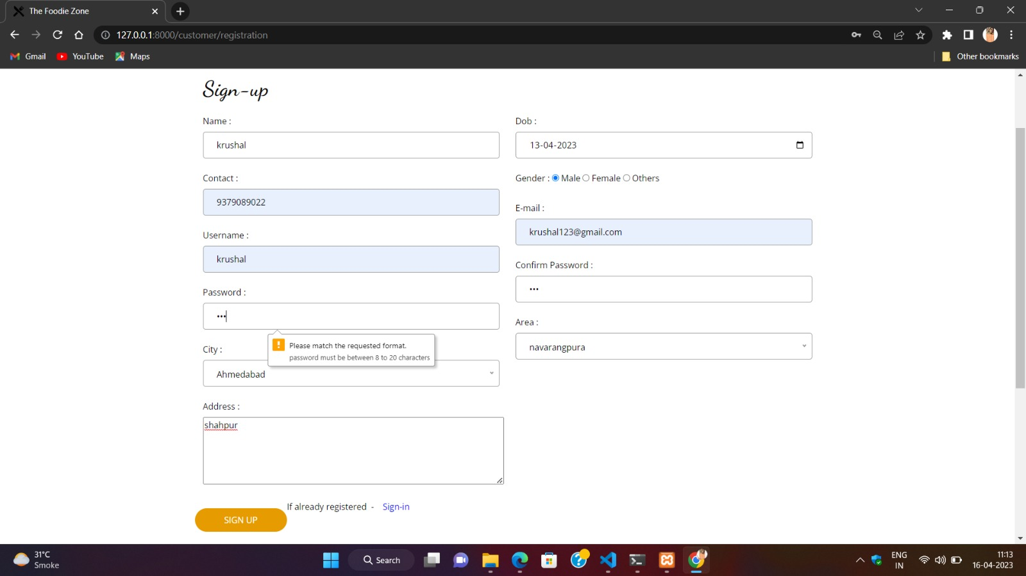

* **Password Field and Confirm Password Field Must Match:**

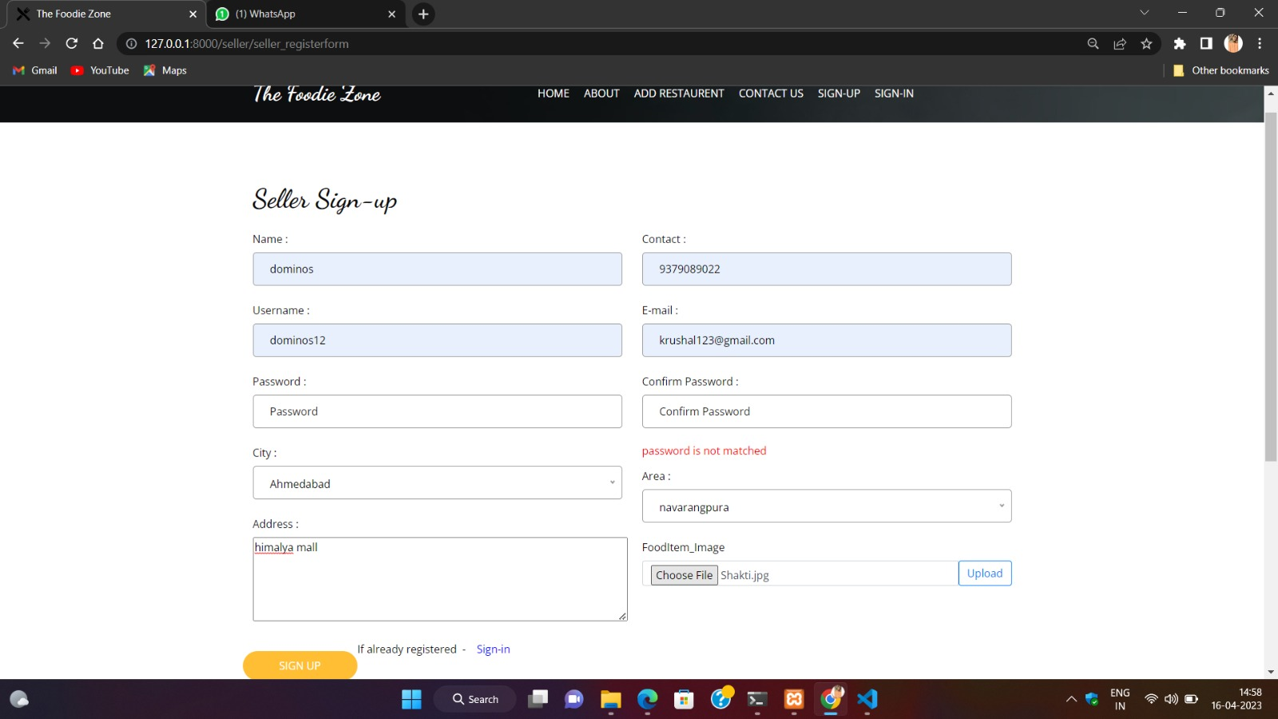

* **Customer/Seller Sign In Page Validation:**

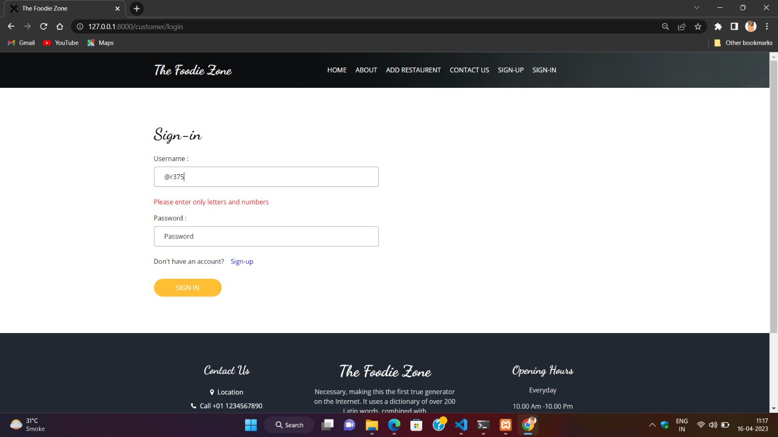

# **CHAPTER-7: SUMMERY**

**7.1 ASSUMPTION:**

* For online Payment, Customer should be having the knowledge of how online transection can be done.
* The Customer should have the basic knowledge of how the online systems works.
* Proper Internet setup is required to run the system smoothly.
* User and Restaurants should be having a valid Gmail id.

**7.2 LIMITATION:**

* Customer cannot track the purchasing order.
* Customer cannot cancel order.
* End to end security is not provided in the system currently.

**7.3 FUTURE SCOPE:**

* We will add our own food delivery system.
* Customer will track purchasing order.
* We will add point system in which users will get point after every order.
* Scope of the System will be expanded to the other cities as well.
  1. **CONCLUSION:**
* We can sum up the entire system in simple words that the System is stable enough to provide the services and ease to the customer. Also the Restaurants can manage order efficiently and can increase their customers.

**Bibliography**

**Site reference:**

[**https://www.w3schools.com/**](https://www.w3schools.com/)

[**https://www.youtube.com/**](https://www.youtube.com/)

[**https://www.zomato.com/**](https://www.zomato.com/)

**Book reference:**

**Software Engineering – A practitioner’s Approach**

**-By Roger S. Pressman**

**System Analysis and Design**

**-By James A. Senn**